|  |  |
| --- | --- |
|  | **FPT ACADEMY INTERNATIONAL**  **FPT – APTECH COMPUTER EDUCATION** |

**Centre Name: ACE-HCMC-2-FPT.**

**Address: 590 Cach Mang Thang 8, District 3, Ho Chi Minh City, Viet Nam.**

**SHUTTLE LAUNDRY ONLINE PROJECT**

|  |  |  |
| --- | --- | --- |
| **Supervisor.** | Ngô Phước Nguyên | |
| **Batch.** | T11910M1 | |
| **Group.** | 2 | |
| **Serial No.** | **Enrollment Number** | **Student Name** |
| 1. | Student1225647 | Nguyễn Ngọc Thạch |
| 2. | Student1235029 | Quách Gia Lâm |
| 3. | Student1215620 | Phan Anh Đức |
| 4. | Student1236866 | Hoàng Toàn Thắng |

**March 2021**

# TABLE OF CONTENT

|  |  |  |  |
| --- | --- | --- | --- |
|  |  | **PAGE** |  |
| 1 | Acknowledgements | 4 |  |
| 2 | Review 1 | 5 |  |
| 3 | Project Sypnosys | 6 |  |
| 4 | Project Analysis | 8 |  |
| 5 | Hardware and software requirement | 10 |  |
| 6 | Review 2 | 14 |  |
| 7 | Project Design | 15 |  |
| 8 | Data Flow Diagram – DFD | 26 |  |
| 9 | UML activity diagram | 36 |  |
| 10 | Entity Relationship Design | 41 |  |
| 11 | Review 3 | 43 |  |
| 12 | Database design | 44 |  |
| 13 | TbPayslip | 45 |  |
| 14 | Technology | 48 |  |
| 15 | Site map | 48 |  |
| 16 | Screen Shot | 49 |  |
| 17 | Payment | 59 |  |
| 18 | Giude for developer | 70 |  |
| 19 | Giuude for employee | 77 |  |
| 20 | TASK SHEET | 82 |  |

ePROJECT3

REVIEW 1

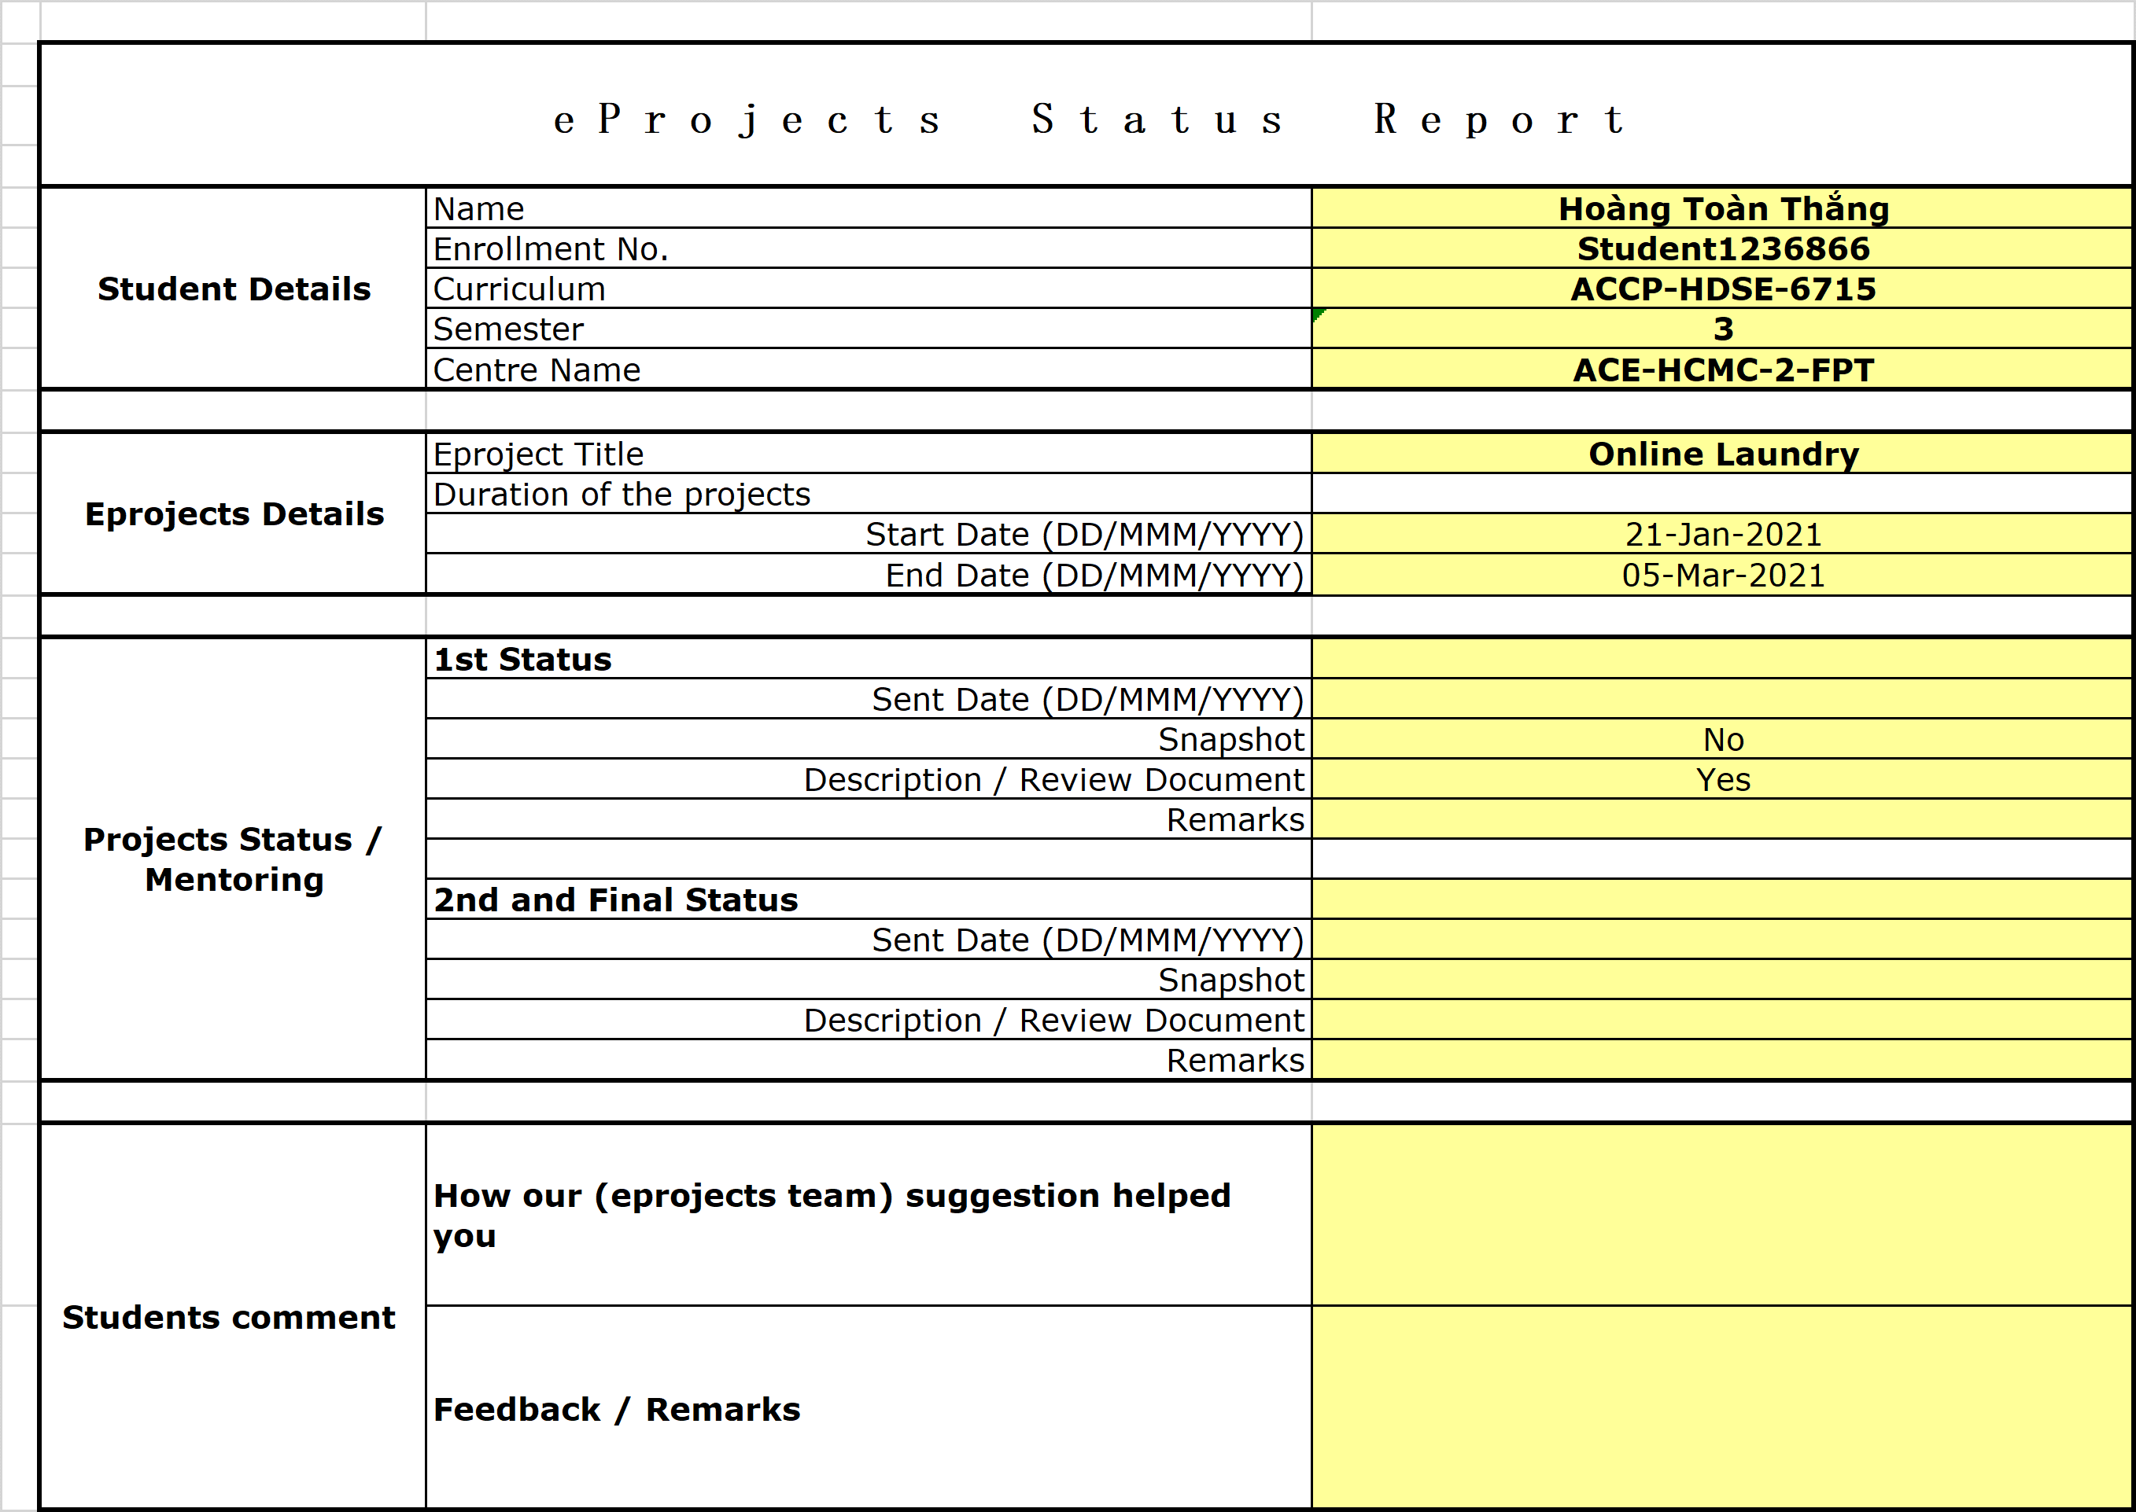

REVIEW 2

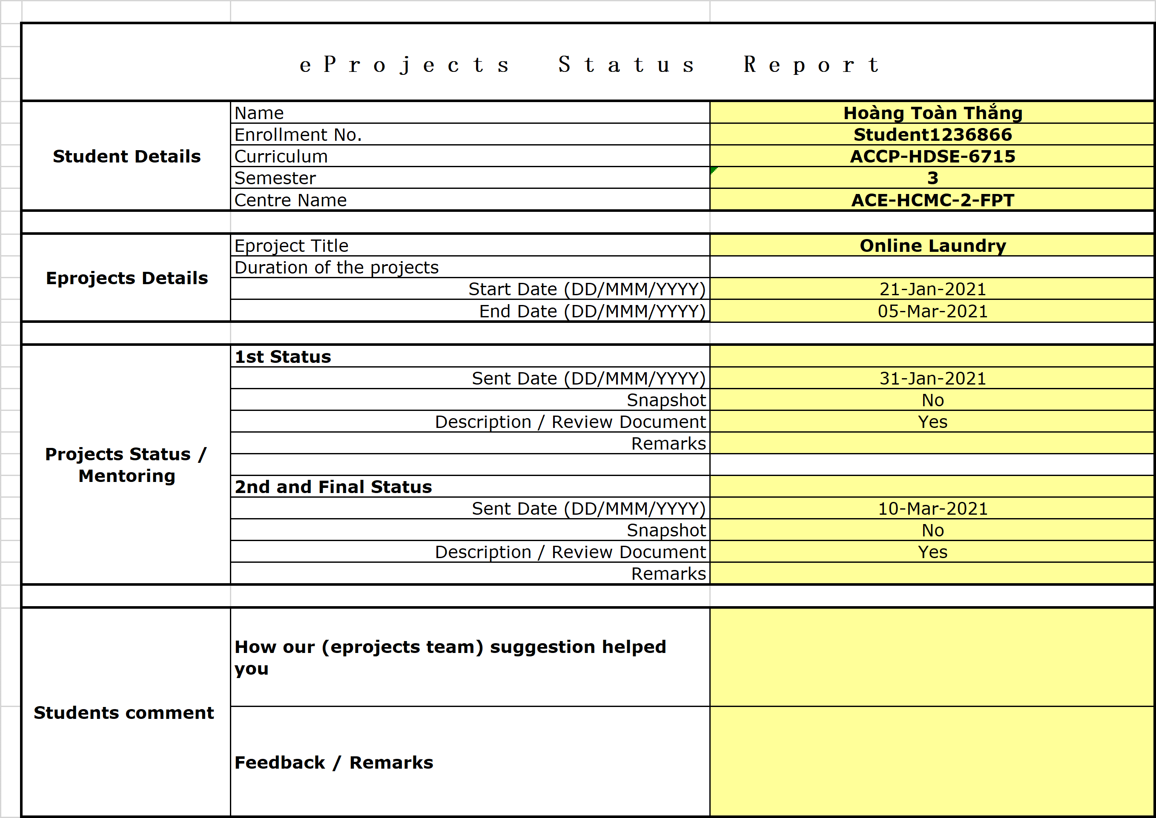

**Acknowledgements**

**Why we use ASP.NET Core:**

We use ASP.Net core to develop our Web_app because of its easier, faster and efficient for developers to build robust and modern web applications.

Some advanced features of ASP.Net core as:

1. Automatic memory management

2. Cross-platform architecture

3. Package management

4. Garbage collection

5. Language independence

6. Asynchronous programming

7. Easy to quick and customize feature-rich enterprise-grade web applications

8. Flawless development of MVC web applications and RESTful APIs

9. Multiple language support

# Why use React instead of JavaScript HTML and CSS

With React we can create custom components, Even if we use React, We're still using JS, HTML, and CSS.

React is a UI library which helps ous manage a lot of things easier with features like Virtual DOM(normal DOM updates are slow), handling data with states, component-based structure etc. We could build a page using elements which make sense for our page ("<home-page>", "<about-page>", "<user-page>") and sub-components on each of those pages to break them up rather than always having to start at the same fine grained level of abstraction that is "<div>", "<span>", "<input>", etc.

**About securiry degree of our website**

Website security is the measures taken to secure a website from cyberattacks, in this state development , this website is low degree security

REVIEW 1

# Project Sypnosys

This eProject is a simulation of real project where the developer team have to design a web application for a company called Shuttle Laundry.

Shuttle Laundry is a well-established laundry service by bringing the convenience to the customer’s door step. It offer picking up and delivery customer’s laundry via outsourcing extenal logistic company. Currently the company has various branch offices in town and a large enough business volume to organize its own pickup/delivery team. The management wants to have a robust app to make the whole service experience as easy as a couple of mouse clicks.

# Project Analysis

## Project Problem Definition

The Developer Team is presented with a task to build a website for a laundry service company. The website is defined as a bridge for service interaction of SHUTTLE LAUNDRY with its costumers that will be devised with appropriate tools to link to back-end database. The team will have to solve the following problems:

* What is SHUTTLE LAUNDRY business/services and what they want to communicate to the users.
* How to categorize and group information into pages to address the priorities of the customer and that of the company. At the same time the user can immediately see what service they are looking for in the order started from the most-used services
* Front end to be pratical and adaptive to the changes of customer needs and request
* Back end and Coputation to be compact, flexible and fluid in arranging and transforming functions and operations of the company.
* As the front-end interaction, how to provide users with smoothest access in the fastest and most attractive manner.
* The website have to have the richest of information without redundancy.

## Project requirement

### Client

SHUTTLE LAUNDRY company

### Project Objective

### System requirement

Online Laundry System has modules to manage Customer Invoices for Pisces, weight, Package, Delivery of Pisces, weight, Package wise, and Barcode Generations many more. It has a fully-fledged Human Resource module to manage the payroll and pay slips.

The modules included in the Online Landry System are as follows:

#### Customer Registration:

This Module Created and Registered new Customer in an application with their necessary and Basic information. Admin has Rights to create, Edit View and Delete all customer information. Search Customer also included in this.

#### Invoice Generation:

After Registered customer, Admin can create Invoice for Customers.

Customer Have three option

1) He/She can choose **Pieces wise Invoice**: He/She can give clothes by piece wise.

2) He can choose **Weight wise Invoice**: He/She can a bunch of cloth weight wise.

3) He can choose **Package wise Invoice:** .He/She can select a package for a month, in that no of Pisces are fixed.

In one screen admin can able to create an invoice and also he can see a last all invoices for a particular customer.

#### Bar Code Generation:

Admin can generate a Bar Code for all selected items for a particular invoice for a customer. After generation, he can able to print barcode on label printer and tag on clothes.

#### Delivery:

Admin can Deliver cloths depend on their status-(Ready, Pending, Delivered), Different Color show Different status, He can also take Remaining payment from and generate an invoice for taking payment.

#### Reports:

Different Report are a presence in a system like

* Customer List,
* Due Payment,
* Daily Collection,
* Garment-wise Collection,
* Cash Book,
* Customer Total Business etc

#### Dash Board

User-Friendly Dashboard available. Graphical Representation is also available. which shows

* Total Business
* Financial Collection.

#### SMS Integration

This system also includes SMS sending on all action and transaction performed for a customer like a Customer Registration, Invoice generation, Payment given etc.

### Hardware and software requirement

#### Hardware requirement

|  |  |  |
| --- | --- | --- |
|  | SERVER | |
| Minimum | Recommended |
| Processor | 800 MHz Intel Pentium III | 2.6 GHz Intel Pentium IV |
| Memory | 2 GB | 4 GB |
| Disk space | 8 GB | 16 GB |
| Monitor | Super-VGA (800x600) or higher resolution monitor | |
| Internet | Internet access is required | |
|  | CLIENT | |
| Processor | 800 MHz Intel Pentium III | |
| Memory | 512 MB | |
| Monitor | Super-VGA (800x600) or higher resolution monitor | |
| Internet | Internet access is required | |

#### Software requirement

|  |  |
| --- | --- |
|  | SERVER |
| Operating System | Windows XP or later |
| Browser | Google Chrome 65.0 |
| Database | Microsoft SQL Server 2017 |
| Software | Microsoft .NET Framework (4.6 or higher) |
|  |
|  | CLIENT |
| Operating System | Windows XP or later |
| Browser | Google Chrome 65.0 |

### Expected delivery date

All deliverable is to be submitted by 5/3/2021

### List of deliverables

Project documentation

User guide

Complete Source code and supporting Files and Folders.

### DEVELOPMENT SOFTWARE

* Windows_NT x64 10.0.18363
* Visual Studio 2019 Express Edition
* Visual Studio Code, version: 1.52.1 (user setup)
* Chrome: 83.0.4103.122
* Node.js: 12.14.1
* Microsoft SQL Server 2014

### TECHNOLOGY

* ASP.NET CORE
* React
* AXIOS
* REDUX
* SASS
* HTML/CSS
* JavaScript
* AJAX
* Jquery

REVIEW 1 – TASK SHEET

|  |  |  |  |  |  |
| --- | --- | --- | --- | --- | --- |
| No. | Contents | Member | Activity Plan | Preparation | |
| Start Date | Actual Days | Status |
| 1 | Project Sypnosys | Hoang Toan Thang  Nguyen Ngoc Thach  Quach Gia Lam  Pham Anh Duc | 05/03/2021 | 3 | Completed |
| 2 | Project Problem Definition |
| 3 | System Requirement |
| 4 | Hardware and Software requirement |
| 5 | Development Software |
| 6 | Technology |
|  |  |

Plan prepared by: Group 2 January 31st, 2020  
 **Group Leader Faculty**

**Hoang Toan Thang Mr. Ngo Phuoc Nguyen**

REVIEW 2

# Project Design

## Design and Struture Analysis

### Use Case Diagram

#### Use case Register and Login



#### Use case Customer Process



#### Use case Employee Process



#### Use case Check Service Locations



#### Use case Order Service



#### Use case Payment



#### Use case Laundry Task Management



#### Use case Pickup Delivery Management



#### Use case Operation Management



#### Use case Invoice Management



#### Use case Business Report Generation



### Data Flow Diagram – DFD

#### Context DFD



#### Level 0 DFD



#### Level 1 DFD – 0.1Customer_Login



#### Level 1 DFD – 0.1Admin_Login



#### Level 1 DFD – 0.1Accountant_Login



#### Level 1 DFD – 0.1Worker_Login



#### Level 1 DFD – 0.2Customer_CustomerProcess



#### Level 1 DFD – 0.2Admin_CustomerProcess



#### Level 1 DFD – 0.2Accountant_CustomerProcess



#### Level 1 DFD – 0.2Worker_CustomerProcess



#### Level 1 DFD – 0.3_EmployeeProcess



### UML activity diagram

#### Activity diagram – 0.1 – Register and Login



#### Activity diagram – 0.2 – Customer Process – Order Service





#### Activity diagram – 0.2 – Customer Process – Operation Management



#### Activity diagram – 0.3 – Employee Process



### Entity Relationship Design



In the last version of building website, we use the following diagram with the same functions:

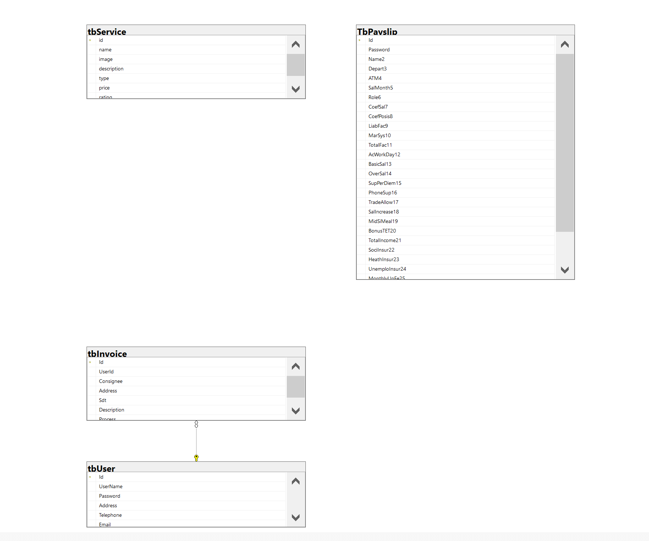

REVIEW 2– TASK SHEET

|  |  |  |  |  |  |
| --- | --- | --- | --- | --- | --- |
| No. | Contents | Member | Activity Plan | Preparation | |
| Start Date | Actual Days | Status |
| 1 | Use Case Diagram | Hoang Toan Thang  Nguyen Ngoc Thach  Quach Gia Lam  Pham Anh Duc | 10/03/2021 | 10 | Completed |
| 2 | Data Flow Diagram |
| 3 | UML Activity Diagram |
| 4 | ERD |

Plan prepared by: Group 2 February 10th, 2020  
 **Group Leader Faculty**

**Hoang Toan Thang Mr. Ngo Phuoc Nguyen**

# REVIEW 3

1. **DATABASE DESIGN**
2. **Database design Diagram**

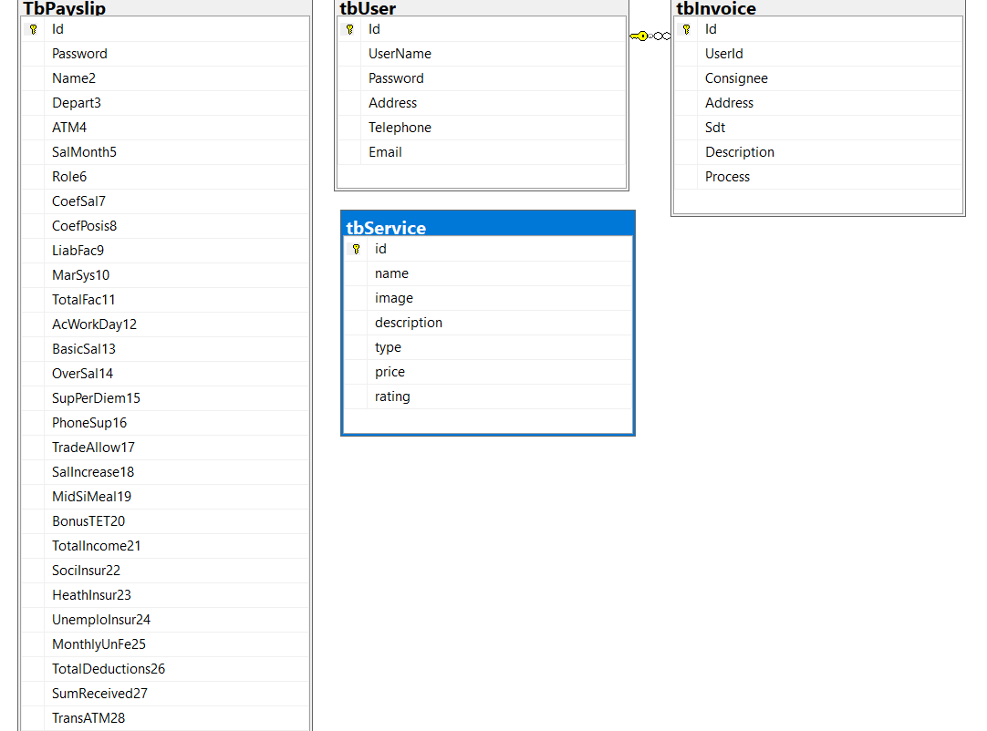

1. **Database Structure**
2. **tbInvoice**

|  |  |  |  |  |  |  |
| --- | --- | --- | --- | --- | --- | --- |
| Key | Field Name | Data type | Null | Default | Reference Table | Description |
| PRIMARY KEY | Id | INT |  | IDENTITY (1, 1) | tbUser | id |
|  | UserId | INT | x |  |  | User id |
|  | Consignee | VARCHAR (30) | x |  |  | consignee |
|  | Address | Text | x |  |  | address |
|  | Sdt | VARCHAR (20) | x |  |  | telephone |
|  | Description | Text | x |  |  | description |
|  | Process | VARCHAR (40) | x |  |  | process |

1. **TbPayslip**

|  |  |  |  |  |  |  |
| --- | --- | --- | --- | --- | --- | --- |
| Key | Field Name | Data type | Null | Default | Reference Table | Description |
| PRIMARY KEY | Id | VARCHAR (10) |  | 001 |  | Id |
|  | Password | VARCHAR (30) | x | 123 |  | Password |
|  | Name2 | VARCHAR (50) | x |  |  | Receiver Name |
|  | Depart3 | VARCHAR (50) | x |  |  | Department |
|  | ATM4 | VARCHAR (50) | x |  |  | ATM account |
|  | SalMonth5 | date | x |  |  | Salary Monthly |
|  | Role6 | bit |  |  |  | Role |
|  | CoefSal7 | VARCHAR (30) | x |  |  | Coefficient Salary |
|  | CoefPosis8 | VARCHAR (30) | x |  |  | Coefficient of position allowance |
|  | LiabFac9 | VARCHAR (30) | x |  |  | Liability factor |
|  | MarSys10 | VARCHAR (30) | x |  |  | Marital system |
|  | TotalFac11 | VARCHAR (50) | x |  |  | Total factor |
|  | AcWorkDay12 | VARCHAR (30) | x |  |  | Actual workdays |
|  | BasicSal13 | VARCHAR (30) | x |  |  | Basic salary |
|  | OverSal14 | VARCHAR (30) | x |  |  | Overtime salary |
|  | SupPerDiem15 | VARCHAR (30) | x |  |  | Support per diem |
|  | PhoneSup16 | VARCHAR (30) | x |  |  | Phone funding support |
|  | TradeAllow17 | VARCHAR (30) | x |  |  | Trade union allowance |
|  | SalIncrease18 | VARCHAR (30) | x |  |  | Salary increase due to good consciousness |
|  | MidSiMeal19 | VARCHAR (30) | x |  |  | Mid shift meal |
|  | BonusTet20 | VARCHAR (30) | x |  |  | Bonuses for holidays and TET |
|  | TotalIncome21 | VARCHAR (50) | x |  |  | **Total incomes** |
|  | SociInsur22 | VARCHAR (30) | x |  |  | Social insurance |
|  | HealthInsur23 | VARCHAR (30) | x |  |  | Health insurance |
|  | UnemploInsur24 | VARCHAR (30) | x |  |  | Unemployment insurance |
|  | MonthlyUnFe25 | VARCHAR (30) | x |  |  | Monthly Union fee |
|  | TotalDedution26 | VARCHAR (50) | x |  |  | **Total deductions** |
|  | SumReceived27 | VARCHAR (50) | x |  |  | Amount received |
|  | TransATM28 | VARCHAR (50) | x |  |  | The amount transferred to ATM |

1. **tbService**

|  |  |  |  |  |  |  |
| --- | --- | --- | --- | --- | --- | --- |
| Key | Field Name | Data type | Null | Default | Reference Table | Description |
| PRIMARY KEY | Id | INT |  | IDENTITY (1, 1) |  | id |
|  | name | VARCHAR (30) | x |  |  | Name |
|  | image | Text | x |  |  | Image |
|  | descripstion | Text | x |  |  | Description |
|  | type | VARCHAR (30) | x |  |  | Type service |
|  | price | float | x |  |  | price |
|  | rating | int | x |  |  | rate |

1. **tbUser**

|  |  |  |  |  |  |  |
| --- | --- | --- | --- | --- | --- | --- |
| Key | Field Name | Data type | Null | Default | Reference Table | Description |
| PRIMARY KEY | Id | INT |  | IDENTITY (1, 1) |  | id |
|  | UserName | VARCHAR (30) | x |  |  | User name |
|  | Password | VARCHAR (30) | x |  |  | password |
|  | Address | Text | x |  |  | address |
|  | Telephone | VARCHAR (30) | x |  |  | telephone |
|  | Email | VARCHAR (50) | x |  |  | email |

1. **Technology**

|  |  |  |
| --- | --- | --- |
| **No** | Component | Requirement |
| **1** | Front End | * Hyper-Text Markup Language (HTML5) * JavaScript * Cascading Style Sheets (CSS) * JQuery * Bootstrap 4, MDBootstrap * ReactJs * PayPal and SMS system |
| **2** | Back End | * ASP.NET Core and MVC framework * Structure Query Language Server (SQL Server) * Web API; Database first method |

1. **Site map**
2. **Cilient Site map**

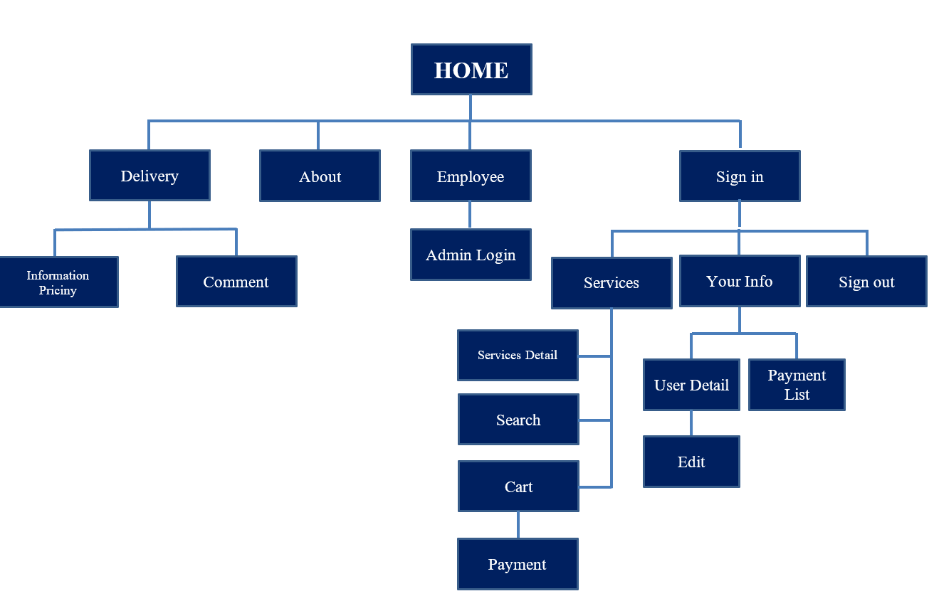

1. **Admin Site map**

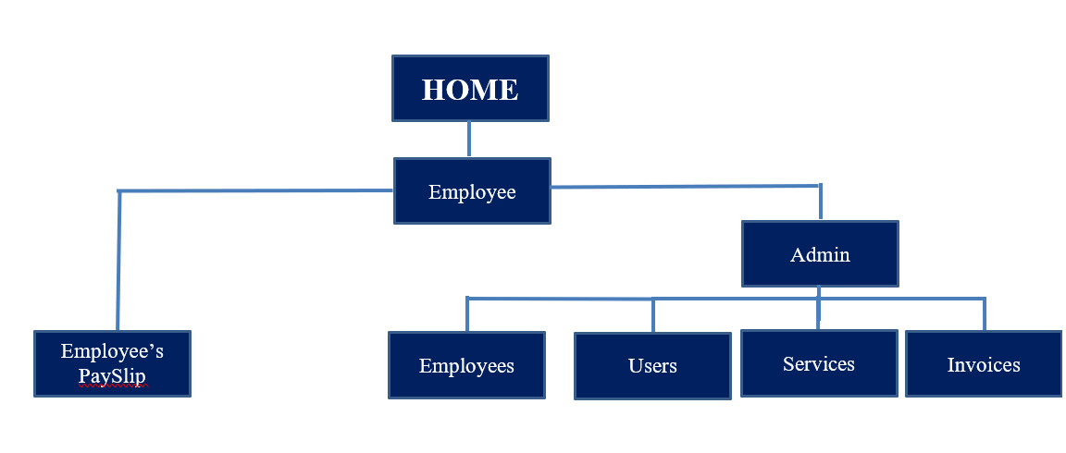

1. **Screen Shot**
2. **Home**

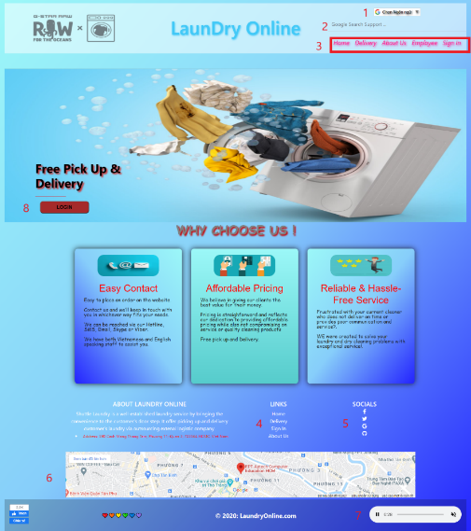

|  |  |  |  |  |  |  |
| --- | --- | --- | --- | --- | --- | --- |
| **No** | **Name** | **Type** | **Validation** | **Event** | **Description** | **Status** |
| 1 | Language | Select-box |  | Click | Choose your language | Enable |
| 2 | Google Search Support | Input-hyperlink |  | Focus | Link to google.com | Enable |
| 3 | Navigation bar | Hyperlink |  | Click | Choose and go to page | Enable |
| 4 | LINKS | Hyperlink |  | Click | Choose and go to page | Enable |
| 5 | SOCIALS | Hyperlink |  | Click | Link to Facebook, Twitch, Google, GitHub | Enable |
| 6 | MAP | Hyperlink |  | Click | The location of the shop | Enable |
| 7 | Music | Button |  | Click | Music | Enable |
| 8 | Login | Button |  | Click | Click to go to Login/ Register page | Enable |

1. **Delivery**

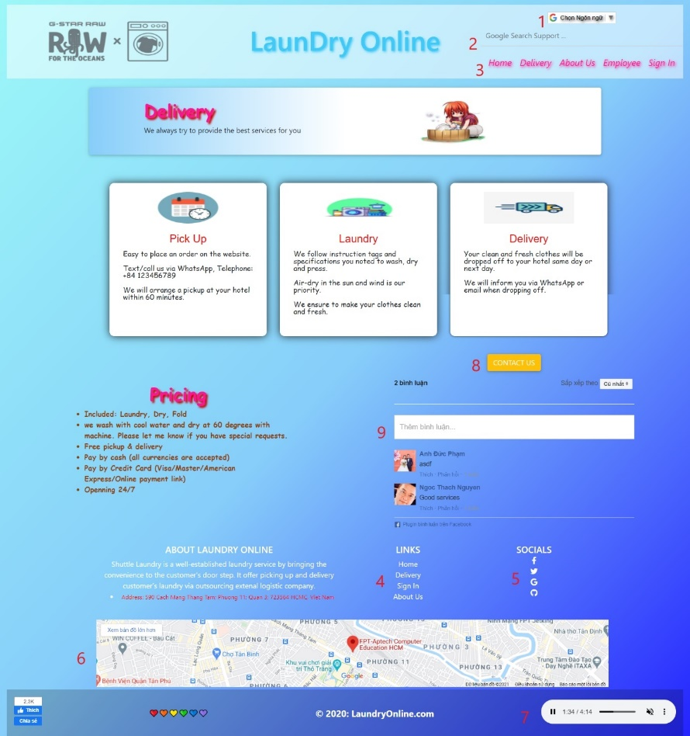

|  |  |  |  |  |  |  |
| --- | --- | --- | --- | --- | --- | --- |
| **No** | **Name** | **Type** | **Validation** | **Event** | **Description** | **Status** |
| 1 | Language | Select-box |  | Click | Choose your language | Enable |
| 2 | Google Search Support | Input-hyperlink |  | Focus | Link to google.com | Enable |
| 3 | Navigation bar | Hyperlink |  | Click | Choose and go to page | Enable |
| 4 | LINKS | Hyperlink |  | Click | Choose and go to page | Enable |
| 5 | SOCIALS | Hyperlink |  | Click | Link to Facebook, twitch, Google, GitHub | Enable |
| 6 | MAP | Hyperlink |  | Click | The location of the shop | Enable |
| 7 | Music | Button |  | Click | Listen music | Enable |
| 8 | Contact Us | Button |  | Click | Click to go to Mail | Enable |
| 9 | Comment | Input |  | Focus | Input your comment | Enable |

1. **About Us**

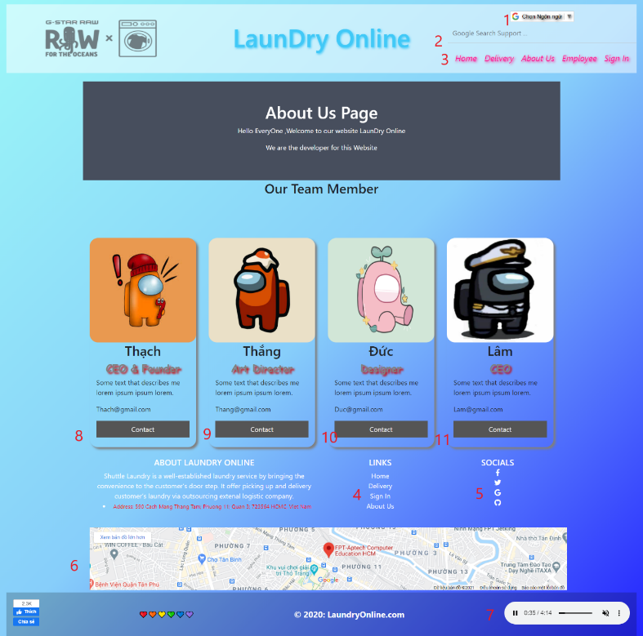

|  |  |  |  |  |  |  |
| --- | --- | --- | --- | --- | --- | --- |
| **No** | **Name** | **Type** | **Validation** | **Event** | **Description** | **Status** |
| 1 | Language | Select-box |  | Click | Choose your language | Enable |
| 2 | Google Search Support | Input-hyperlink |  | Focus | Link to google.com | Enable |
| 3 | Navigation bar | Hyperlink |  | Click | Choose and go to page | Enable |
| 4 | LINKS | Hyperlink |  | Click | Chooes and go to page | Enable |
| 5 | SOCIALS | Hyperlink |  | Click | Link to Facebook, Twitch, Google, GitHub | Enable |
| 6 | MAP | Hyperlink |  | Click | The location of the shop | Enable |
| 7 | Music | Button |  | Click | Listen music | Enable |
| 8 | Contact | Button |  | Click | Mail to Thach@gmail.com | Enable |
| 9 | Contact | Button |  | Click | Mail to Thang@gmail.com | Enable |
| 10 | Contact | Button |  | Click | Mail to Duc@gmail.com | Enable |
| 11 | Contact | Button |  | Click | Mail to Lam@gmail.com | Enable |

1. **Sign In**

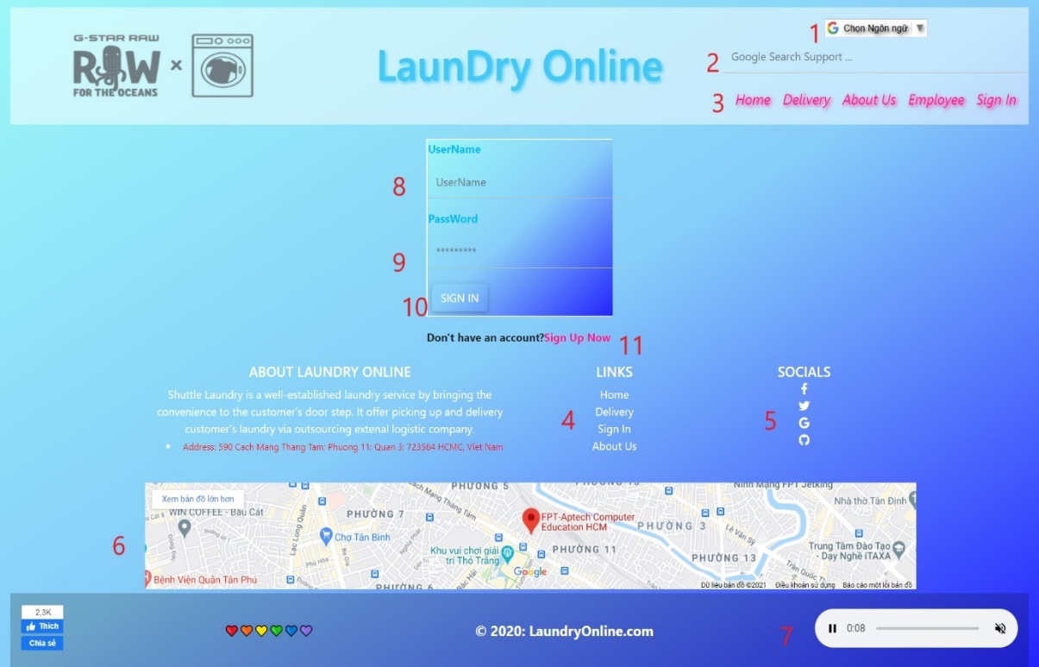

|  |  |  |  |  |  |  |
| --- | --- | --- | --- | --- | --- | --- |
| **No** | **Name** | **Type** | **Validation** | **Event** | **Description** | **Status** |
| 1 | Language | Select-box |  | Click | Choose your language | Enable |
| 2 | Google Search Support | Input-hyperlink |  | Focus | Link to google.com | Enable |
| 3 | Navigation bar | Hyperlink |  | Click | Choose and go to page | Enable |
| 4 | LINKS | Hyperlink |  | Click | Choose and go to page | Enable |
| 5 | SOCIALS | Hyperlink |  | Click | Link to Facebook, twitch, Google, GitHub | Enable |
| 6 | MAP | Hyperlink |  | Click | The location of the shop | Enable |
| 7 | Music | Button |  | Click | Listen music | Enable |
| 8 | Username | Input | Required | Focus | Input Username | Enable |
| 9 | Password | Input | Required | Focus | Input Password | Enable |
| 10 | Sign In | Button |  | Click | Log in | Enable |
| 11 | Register | Hyperlink |  | click | Click to go to Register Page | Enable |

1. **Sign out (Register)**

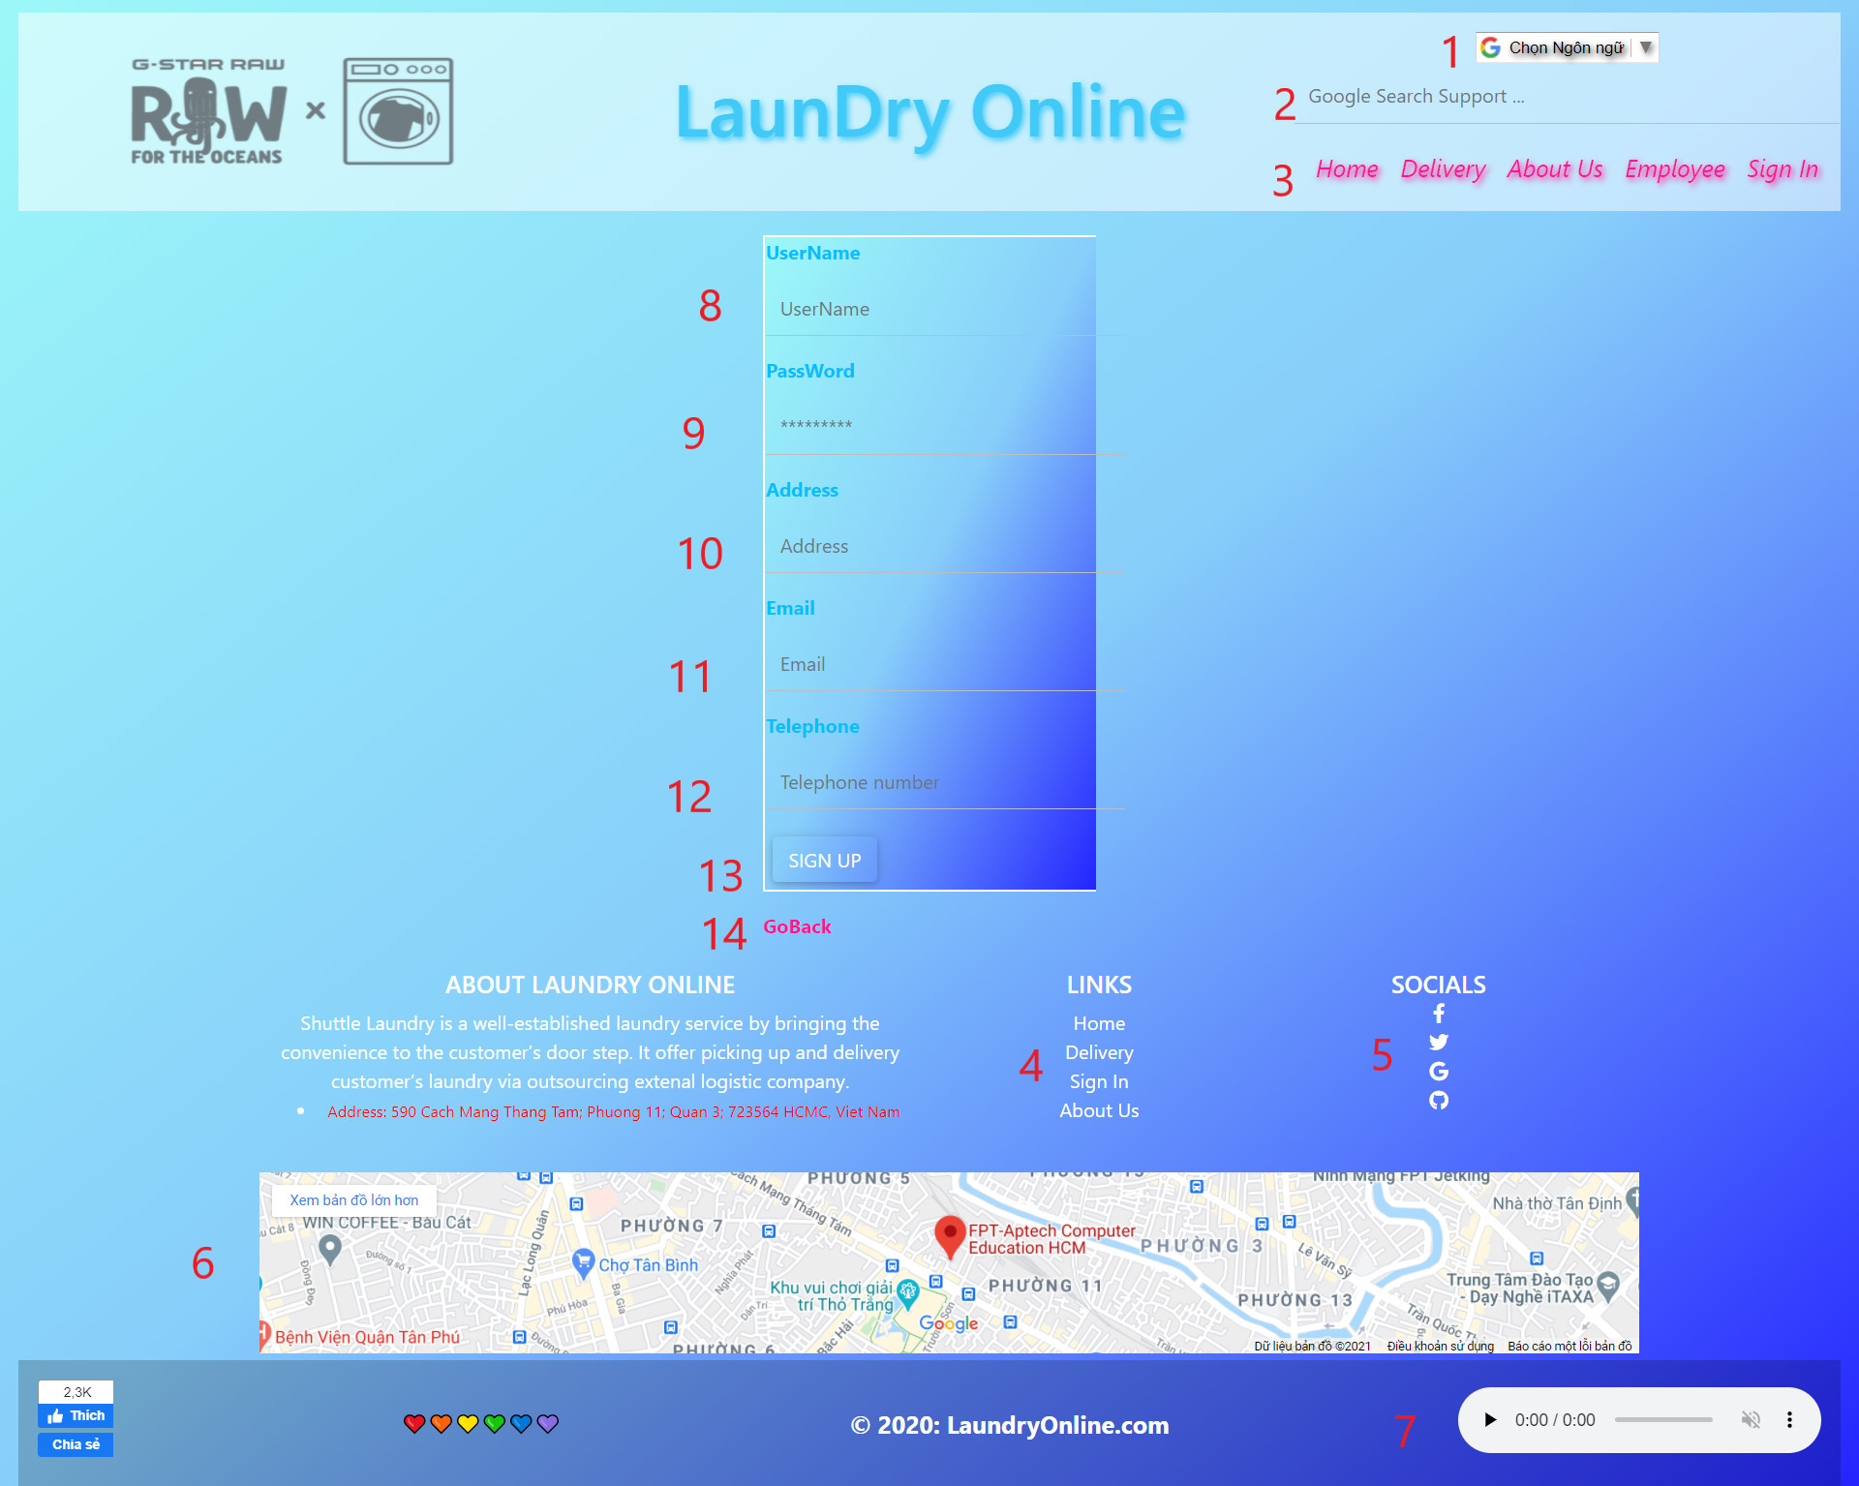

|  |  |  |  |  |  |  |
| --- | --- | --- | --- | --- | --- | --- |
| **No** | **Name** | **Type** | **Validation** | **Event** | **Description** | **Status** |
| 1 | Language | Select-box |  | Click | Choose your language | Enable |
| 2 | Google Search Support | Input-hyperlink |  | Focus | Link to google.com | Enable |
| 3 | Navigation bar | Hyperlink |  | Click | Choose and go to page | Enable |
| 4 | LINKS | Hyperlink |  | Click | Choose and go to page | Enable |
| 5 | SOCIALS | Hyperlink |  | Click | Link to Facebook, twitch, Google, GitHub | Enable |
| 6 | MAP | Hyperlink |  | Click | The location of the shop | Enable |
| 7 | Music | Button |  | Click | Listen music | Enable |
| 8 | Username | Input | Required | Focus | Input Username | Enable |
| 9 | Password | Input | Required | Focus | Input Password | Enable |
| 10 | Address | Input | Required | Focus | Input Address | Enable |
| 11 | Email | Input | Required | Focus | Input Email | Enable |
| 12 | Telephone | Input | Required | Focus | Input Phone Number | Enable |
| 13 | SIGN UP | Button |  | Click | Alert Sign Up Success | Enable |
| 14 | GoBack | HyperLink |  | Click | Go to Sign in page | Enable |

**6.Services**

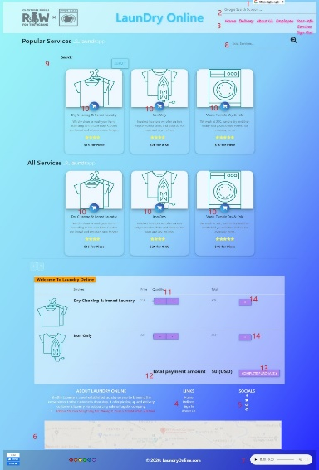

|  |  |  |  |  |  |  |
| --- | --- | --- | --- | --- | --- | --- |
| **No** | **Name** | **Type** | **Validation** | **Event** | **Description** | **Status** |
| 1 | Language | Select-box |  | Click | Choose your language | Enable |
| 2 | Google Search Support | Input-hyperlink |  | Focus | Link to google.com | Enable |
| 3 | Navigation bar | Hyperlink |  | Click | Choose and go to page | Enable |
| 4 | LINKS | Hyperlink |  | Click | Choose and go to page | Enable |
| 5 | SOCIALS | Hyperlink |  | Click | Link to Facebook, twitch, Google, GitHub | Enable |
| 6 | MAP | Hyperlink |  | Click | The location of the shop | Enable |
| 7 | Music | Button |  | Click | Listen music | Enable |
| 8 | Exist Services | Input,icon |  | Focus, click | Input and click to Search | Enable |
| 9 | Search | Input, button |  | Focus, click | Input and click to Search | Enable |
| 10 | Cart | Icon |  | Click | add your services into Cart | Enable |
| 11 | Quantity | Button |  | Click | + ; - quantity | Enable |
| 12 | Total Payment Amount | Text |  |  | Show total payment amount USD | Enable |
| 13 | Complete Purchase | Button |  | Click | Go to Payment | Enable |
| 14 | x | Button |  | Click | Delete service | Enable |

1. **Payment**

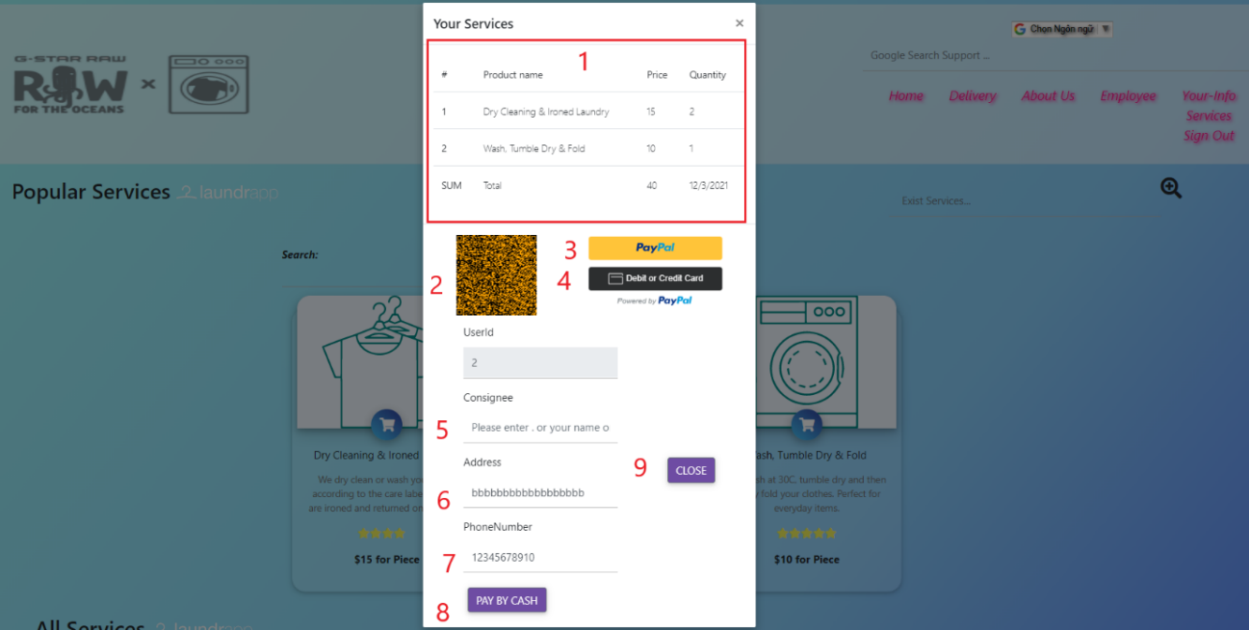

|  |  |  |  |  |  |  |
| --- | --- | --- | --- | --- | --- | --- |
| **No** | **Name** | **Type** | **Validation** | **Event** | **Description** | **Status** |
| 1 | Your Survices | Text |  |  | Show your Services Details | Enable |
| 2 | QR | Scan |  |  | Scan QR code | Enable |
| 3 | Paypal | Button |  | Click | Click to pay | Unable |
| 4 | Debit or Credit Card | Button |  | Click | Click to pay | Unable |
| 5 | Consignee | InPut |  | Focus | Add consignee | Enable |
| 6 | Address | Input |  | Focus | Add Address | Enable |
| 7 | Phone Number | Input |  | Focus | Add Phone Number | Enable |
| 8 | Pay By Cash | Button |  | Click | Click to pay | Enable |
| 9 | Close | Button |  | Click | Close this page and go back Services page | Enable |

Qrcode system automatically creates cart according to customer requirements



We will use qrcode software to read the code

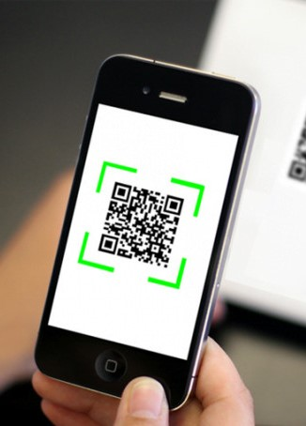

# Note

The PayPal and SMS current not working:

To do this work you have to:

* PayPal:

## **Create a PayPal account**

## **Create a REST API app**

## **Get your API credentials**

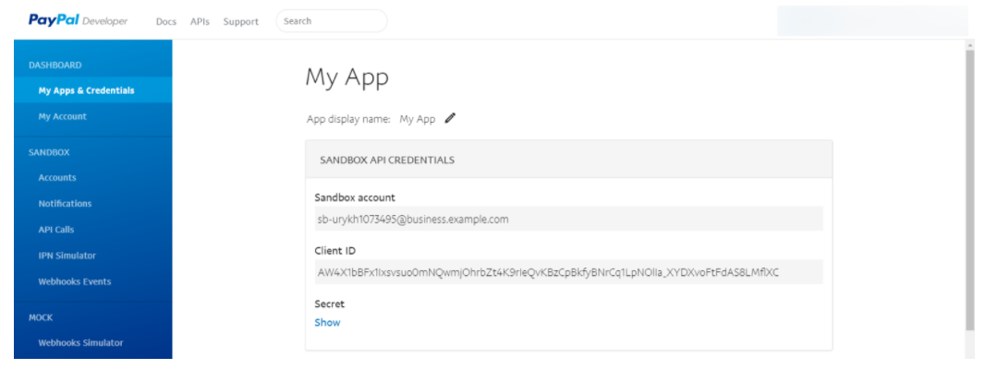

1. You will have Sandbox account where you can manager your transactions in the paypal and the Client ID

For more info: <https://developer.paypal.com/docs/get-started/>

b)Now go to the project3-client in folder public, find the index.html file ,go to line 90 and change the sb with Client ID to run the paypal feature.



For more info: <https://youtu.be/IXxEdhA7fig>

Else other ways: <https://www.paypal.com/us/smarthelp/article/FAQ3629>

* SMS

## **Create a RapidAPI account on website**

<https://rapidapi.com/stefanluciandeleanu/api/sms-voice-messages?utm_source=google&utm_medium=display&utm_campaign=pressSub&utm_term=_&utm_content=none&gclid=CjwKCAiAm-2BBhANEiwAe7eyFNrvrQrEDBkaBugX9Pphw2jA7ZVwA8QuF6_WmzV0q5kAPTtx65yYbxoCRv4QAvD_BwE>

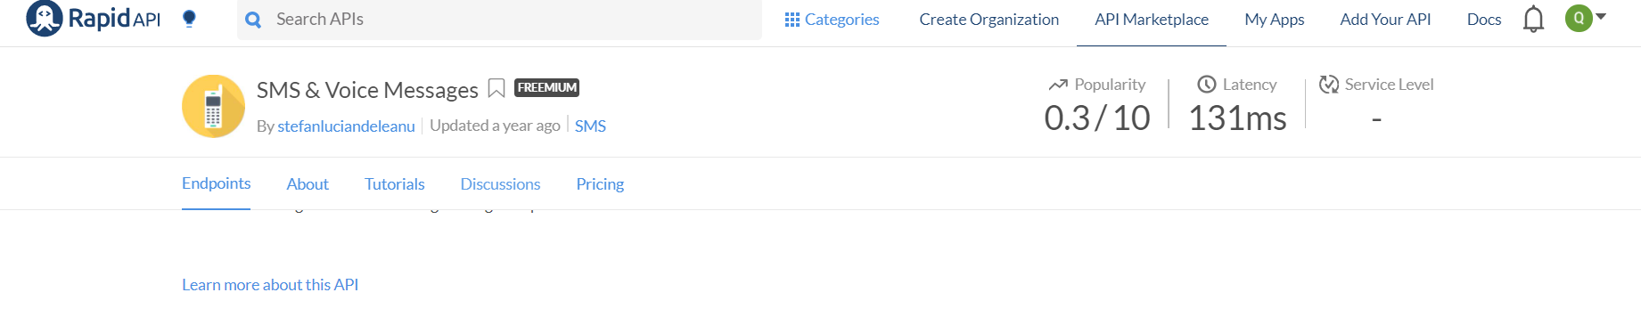

You will have your api id for sms

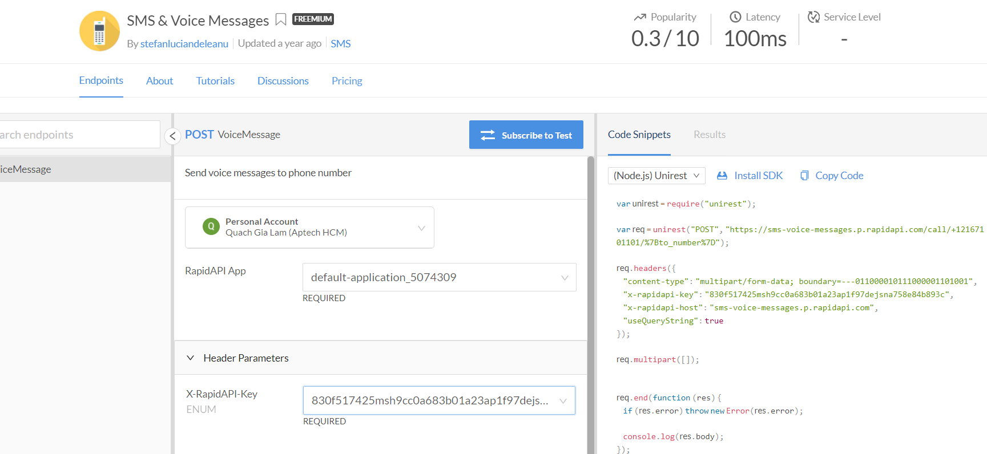

## **You will pay the cost to run sms**

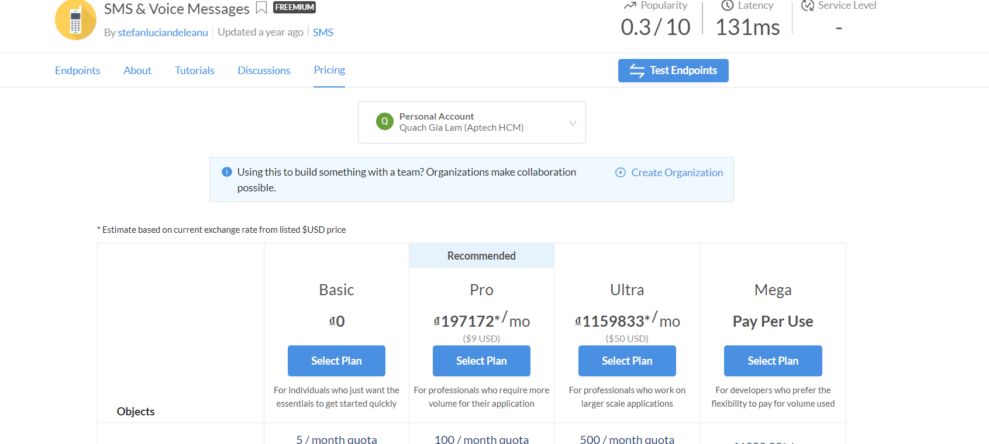

## **Now go to code**

We will change the line key id to run sms

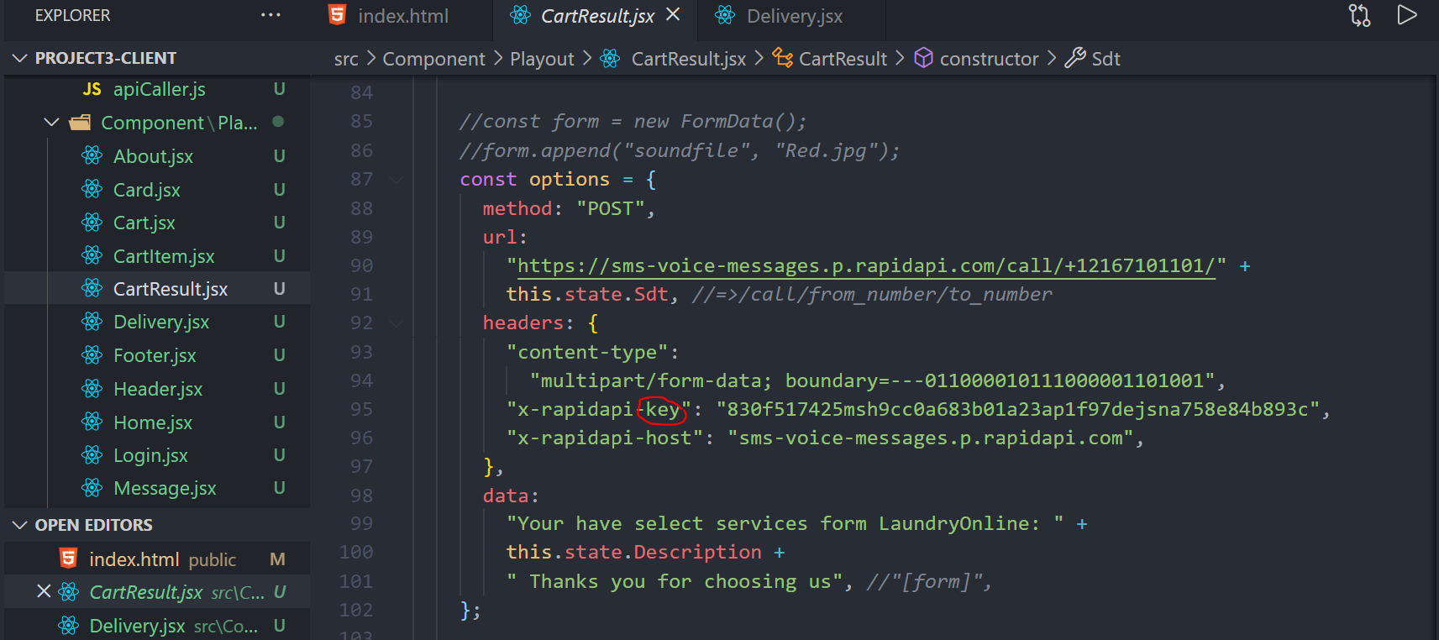

1. **Your-Info**

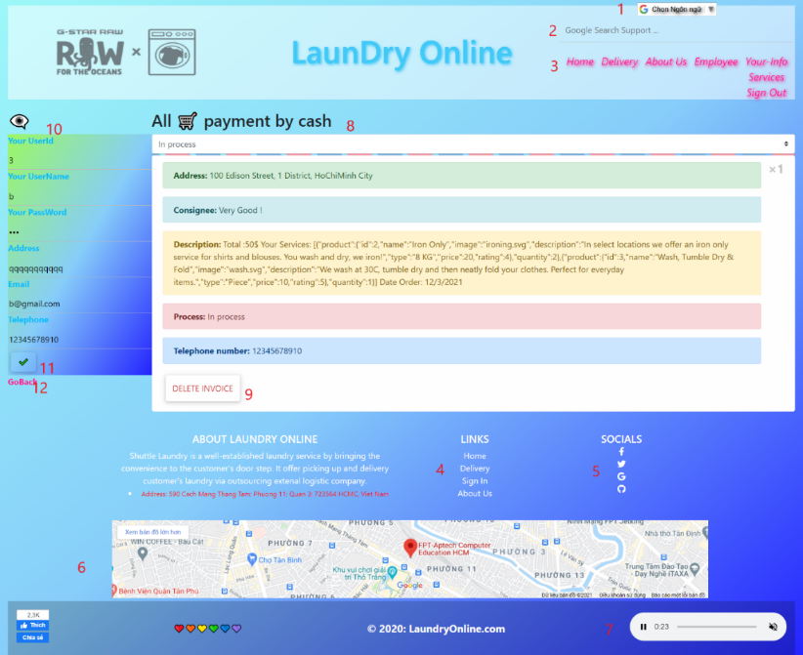

|  |  |  |  |  |  |  |
| --- | --- | --- | --- | --- | --- | --- |
| **No** | **Name** | **Type** | **Validation** | **Event** | **Description** | **Status** |
| 1 | Language | Select-box |  | Click | Choose your language | Enable |
| 2 | Google Search Support | Input-hyperlink |  | Focus | Link to google.com | Enable |
| 3 | Navigation bar | Hyperlink |  | Click | Choose and go to page | Enable |
| 4 | LINKS | Hyperlink |  | Click | Chooes and go to page | Enable |
| 5 | SOCIALS | Hyperlink |  | Click | Link to facebook, twitch,Google,GitHub | Enable |
| 6 | MAP | Hyperlink |  | Click | The location of the shop | Enable |
| 7 | Music | Button |  | Click | Listen music | Enable |
| 8 | All payment | Text |  |  | Show all your Cart Payment by Cash | Enable |
| 9 | Delete Invoice | Button |  | Click | Delete your history payment | Enable |
| 10 | Profile |  |  | Focus | You can Edit your information here | Enable |
| 11 | Ok | Icon |  | Click | Click to Edit your information | Enable |
| 12 | GoBack | Button |  | Click | Go to Services page | Enable |

1. **Employee**

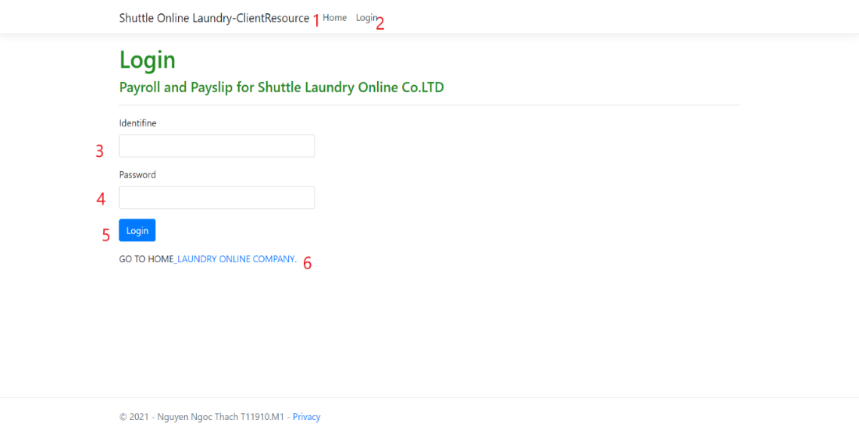

|  |  |  |  |  |  |  |
| --- | --- | --- | --- | --- | --- | --- |
| **No** | **Name** | **Type** | **Validation** | **Event** | **Description** | **Status** |
| 1 | Home | Hyperlink |  | Click | Go to Employee page | Enable |
| 2 | Login | Hyperlink |  | Click | Go to Employee Login page | Enable |
| 3 | Identifine | Input | Required | Focus | Admin: 001  Employee: 001,…. | Enable |
| 4 | Password | Input | Required | Focus | Admin: 123  Employee 001: 123 |  |
| 5 | Login | Button |  | Click | Go to admin page or employee page | Enable |
| 6 | Laundry Online company | Hyperlink |  | Click | Go to Home page | Enable |

1. **Payslip Table**

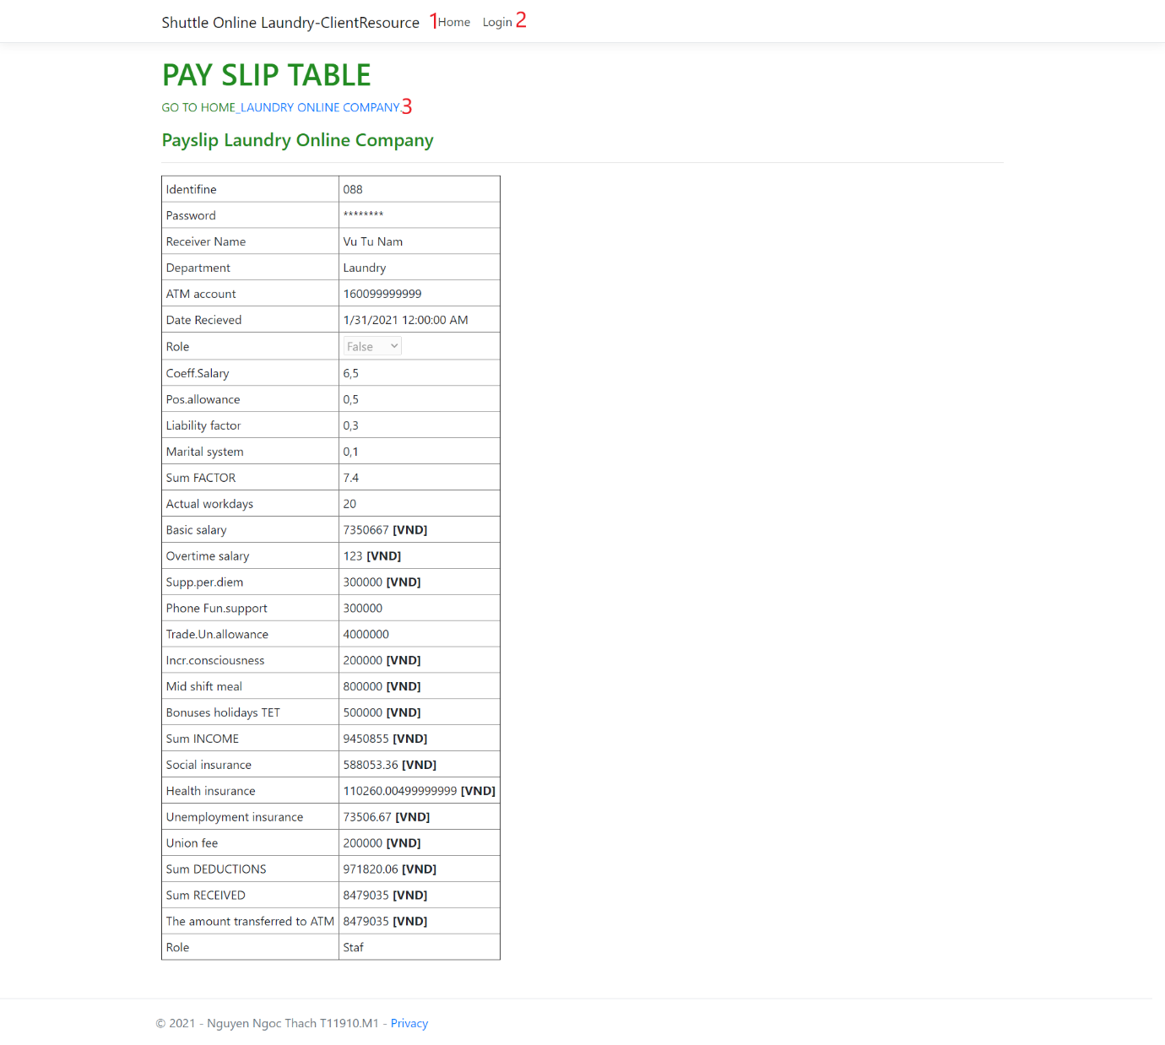

|  |  |  |  |  |  |  |
| --- | --- | --- | --- | --- | --- | --- |
| **No** | **Name** | **Type** | **Validation** | **Event** | **Description** | **Status** |
| 1 | Home | Hyperlink |  | Click | Go to Login page | Enable |
| 2 | Login | Hyperlink |  | Click | Go to Employee Login page | Enable |
| 3 | Laundry Online company | Hyperlink |  | Click | Go to Home page | Enable |

1. **Admin Page**

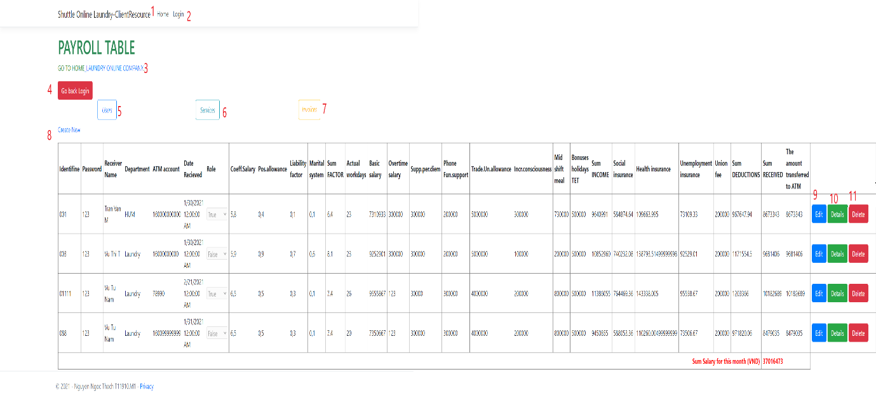

|  |  |  |  |  |  |  |
| --- | --- | --- | --- | --- | --- | --- |
| **No** | **Name** | **Type** | **Validation** | **Event** | **Description** | **Status** |
| 1 | Home | Hyperlink |  | Click | Go to admid page | Enable |
| 2 | Login | Hyperlink |  | Click | Go to Employee Login page | Enable |
| 3 | Laundry Online company | Hyperlink |  | Click | Go to Home page | Enable |
| 4 | Go Back Login | Button |  | Click | Go to Employee Login page | Enable |
| 5 | Users | Button |  | Click | Go to Users page | Enable |
| 6 | Services | Button |  | Click | Go to Service Detail | Enable |
| 7 | Invoices | Button |  | Click | Go to Invoices detail | Enable |
| 8 | Create new | Hyperlink |  | Click | Go to Create new Employee | Enable |
| 9 | Edit | Button |  | Click | Go to Edit employee detail | Enable |
| 10 | Details | Button |  | Click | Go to Employee Payslip | Enable |
| 11 | Delete | Button |  | Click | Delete Employee | Enable |

1. **Customers (Users)**

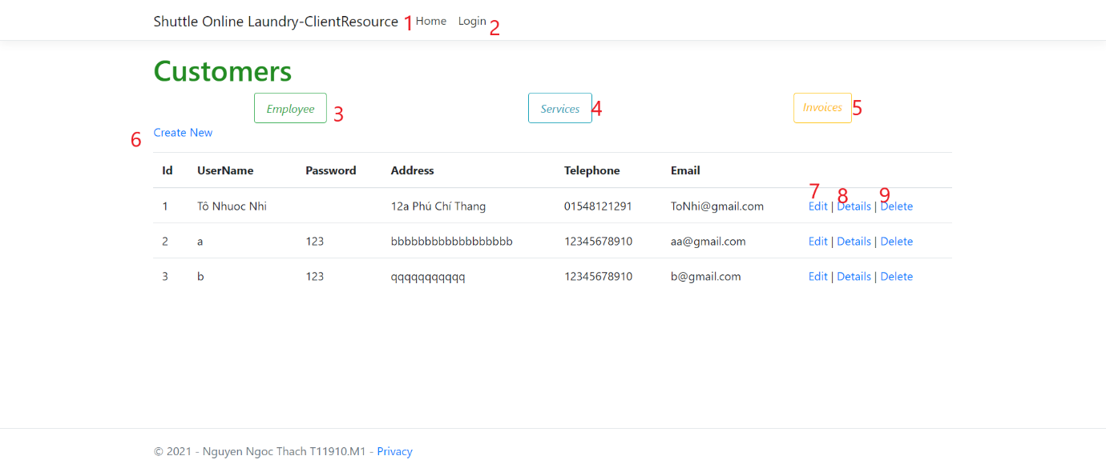

|  |  |  |  |  |  |  |
| --- | --- | --- | --- | --- | --- | --- |
| **No** | **Name** | **Type** | **Validation** | **Event** | **Description** | **Status** |
| 1 | Home | Hyperlink |  | Click | Go to admid page | Enable |
| 2 | Login | Hyperlink |  | Click | Go to Employee Login page | Enable |
| 3 | Employee | Button |  | Click | Go to Employee page | Enable |
| 4 | Services | Button |  | Click | Go to Service Detail | Enable |
| 5 | Invoices | Button |  | Click | Go to Invoices detail | Enable |
| 6 | Create new | Hyperlink |  | Click | Go to Create new Customer User | Enable |
| 7 | Edit | Hyperlink |  | Click | Edit customer user details | Enable |
| 8 | Details | Hyperlink |  | Click | Show customer Details | Enable |
| 9 | Delete | Hyperlink |  | Click | Delete customer User | Enable |

1. **Service Details**

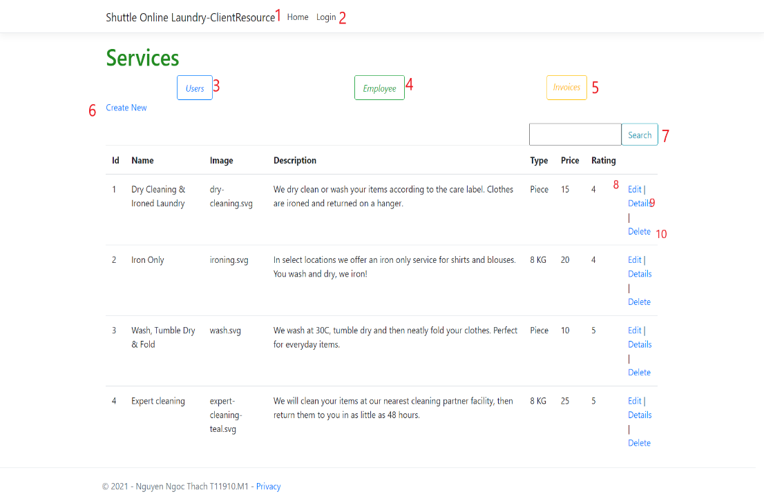

|  |  |  |  |  |  |  |
| --- | --- | --- | --- | --- | --- | --- |
| **No** | **Name** | **Type** | **Validation** | **Event** | **Description** | **Status** |
| 1 | Home | Hyperlink |  | Click | Go to admid page | Enable |
| 2 | Login | Hyperlink |  | Click | Go to Employee Login page | Enable |
| 3 | Users | Button |  | Click | Go to Users page | Enable |
| 4 | Employee | Button |  | Click | Go to Employee page | Enable |
| 5 | Invoices | Button |  | Click | Go to Invoices detail | Enable |
| 6 | Create new | Hyperlink |  | Click | Go to Create new Service | Enable |
| 7 | Search | Input / Button |  | Focus / Click | Search services | Enable |
| 8 | Edit | Hyperlink |  | Click | Edit service details | Enable |
| 9 | Details | Hyperlink |  | Click | Show service Details | Enable |
| 10 | Delete | Hyperlink |  | Click | Delete service | Enable |

1. **Invoices**

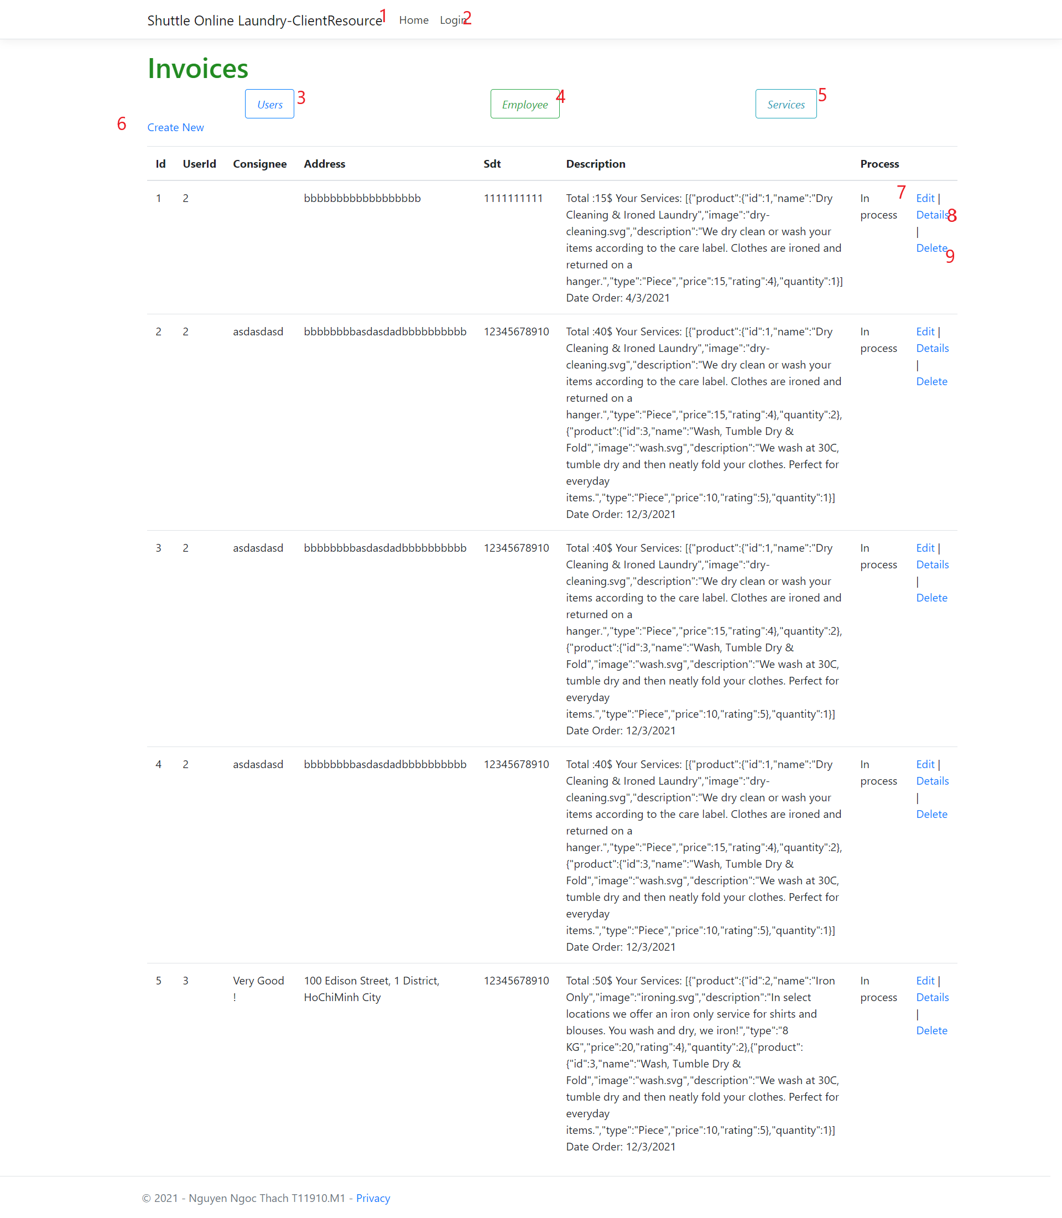

|  |  |  |  |  |  |  |
| --- | --- | --- | --- | --- | --- | --- |
| **No** | **Name** | **Type** | **Validation** | **Event** | **Description** | **Status** |
| 1 | Home | Hyperlink |  | Click | Go to admid page | Enable |
| 2 | Login | Hyperlink |  | Click | Go to Employee Login page | Enable |
| 3 | Users | Button |  | Click | Go to Users page | Enable |
| 4 | Employee | Button |  | Click | Go to Employee page | Enable |
| 5 | Services | Button |  | Click | Go to Service Detail | Enable |
| 6 | Create new | Hyperlink |  | Click | Go to Create new Invoices | Enable |
| 7 | Edit | Hyperlink |  | Click | Edit Invoices details | Enable |
| 8 | Details | Hyperlink |  | Click | Show Invoices Details | Enable |
| 9 | Delete | Hyperlink |  | Click | Delete Invoice | Enable |

**IV-GUIDE**

* 1. - **GUIDE FOR DEVELOPER**

General step follows:

Step1: Open file database in the package Group2New : 

Built Database named EmployeeResourceBD in Server’ SQL :

CREATE DATABASE EmployeeResourceDB

USE EmployeeResourceDB

Built Tables:

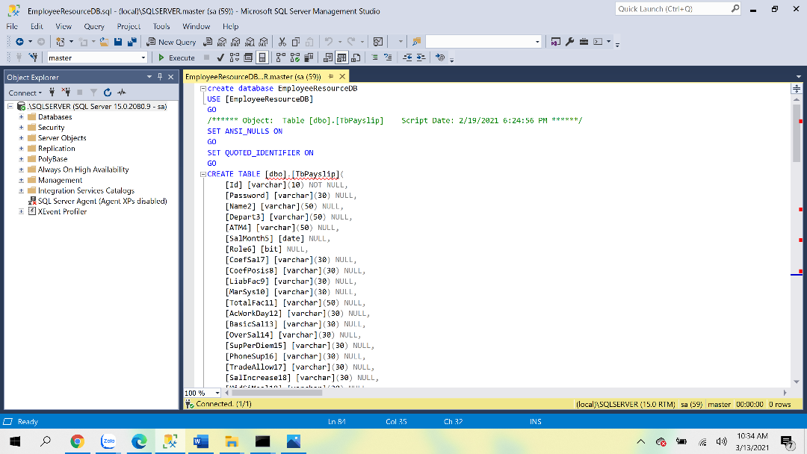

Note: That values like scripted file have to create in the database

Insert into tbService ([name],[image],[description],[type],price,rating) values

('Dry Cleaning & Ironed Laundry','dry-cleaning.svg','We dry clean or wash your items according to the care label. Clothes are ironed and returned on a hanger.','Piece',15,4),

('Iron Only','ironing.svg','In select locations we offer an iron only service for shirts and blouses. You wash and dry, we iron!','8 KG',20,4),

('Wash, Tumble Dry & Fold','wash.svg','We wash at 30C, tumble dry and then neatly fold your clothes. Perfect for everyday items.','Piece',10,5),

('Expert cleaning','expert-cleaning-teal.svg','We will clean your items at our nearest cleaning partner facility, then return them to you in as little as 48 hours.','8 KG',25,5);

Insert into tbUser (UserName,[Address],Telephone,Email) values

('Tô Nhuoc Nhi','12a Phú Chí Thang','01548121291','ToNhi@gmail.com')

Next step 2: => Run file **ServerLaundryOnline.sln** in package ServerLaundryOnline => open file Appsettings.json in ServerLaundryOnline project, repair name SQL Server in developer site with new database named EmployeeResoureceDB

1/- Data Source=(Server’ SQL name);

2/- Initial Catalog = EmployeeResourceDB

"AllowedHosts": "*",

"ConnectionStrings": {

"DefaultConnection": "Data Source=**.\\SQLSERVER**; Initial Catalog = **EmployeeResourceDB**; uid=sa;pwd=123"}

Next step 3: Run project

Two ways to run the project is that:

1/- **First way:** Run file “**run-apps**” in the package **Group2New**

2/- **Second way:** START “ServerLaundryOnline.sln”, then Open package “ClientReact” in folder Group2New => cmd => Code . => npm start

File **run-apps** as follow:

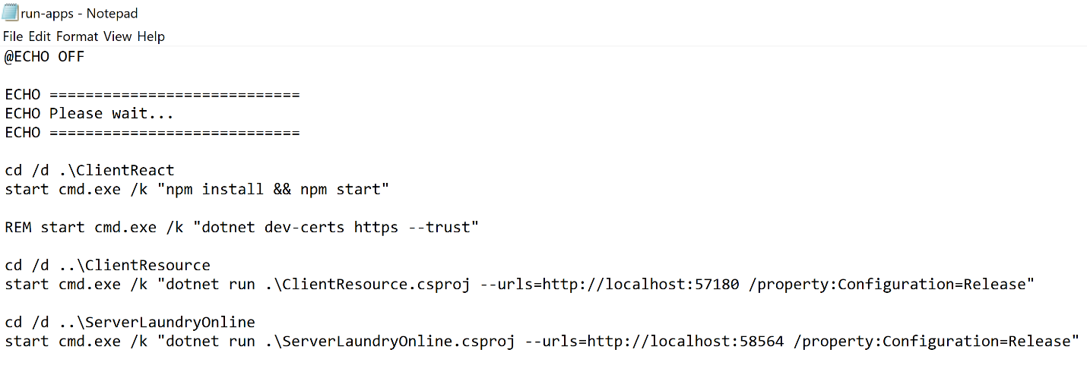

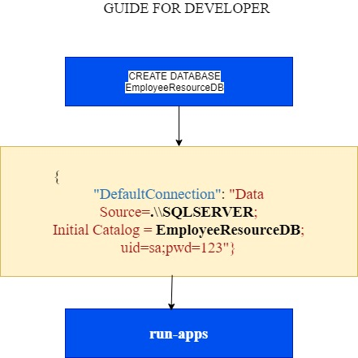

* 1. – **GUIDE FOR USER**

**4.2.1- USER AS CLIENT**

For the first time, that user use our service

Sign in => Sing out now

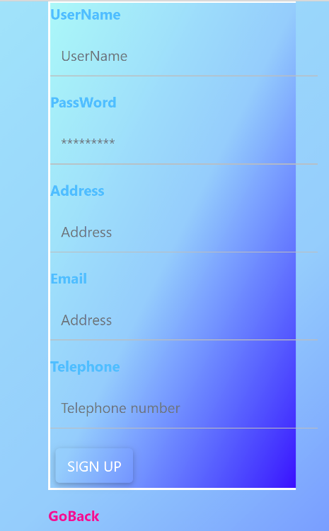

Then Sing in

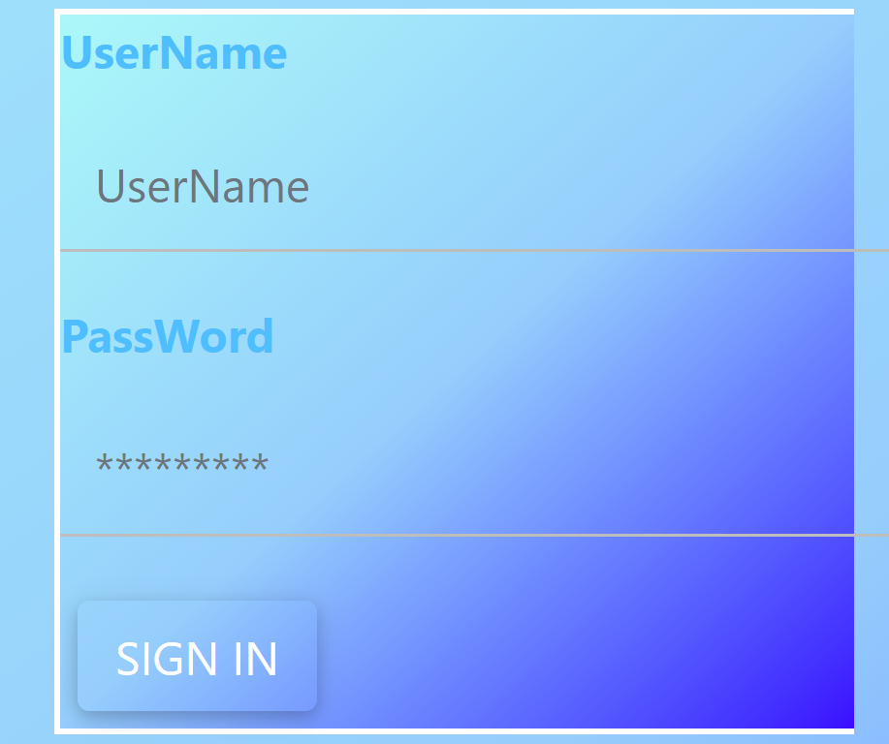

=> Chose service package

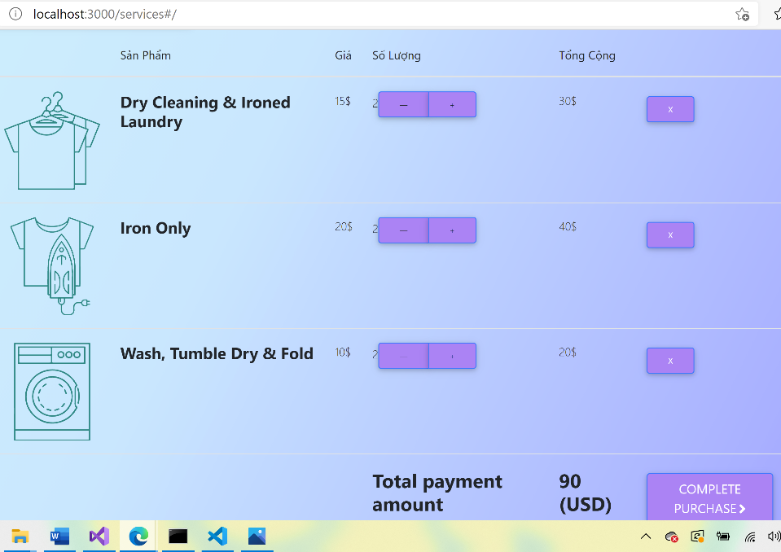

=> chose payment type

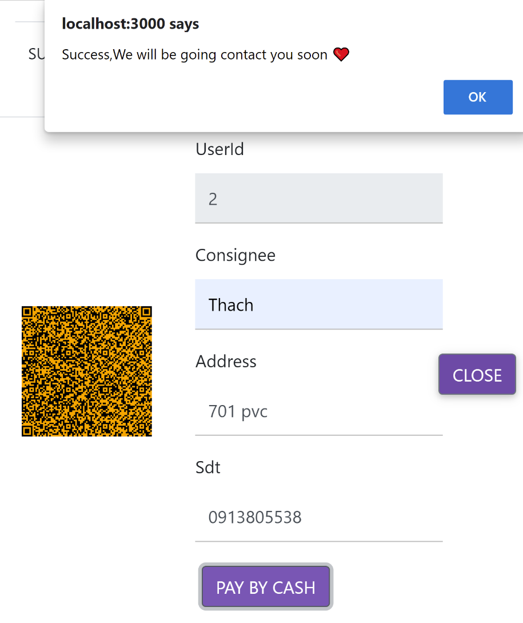

The next time you can instantly **sign in**

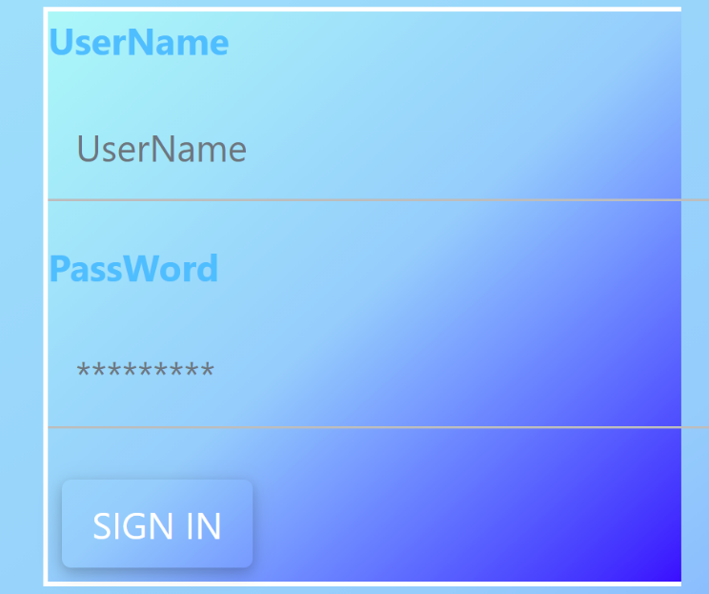

All next step to use our service like below.

**4.2.2 - GUIDER FOR EMPLOYEES**

**4.2.2.1/- For Employee as staf:** Employee => Id (In this case Id = 002; 003; …) => Password (In this case default value is 123) =.> Payslip table

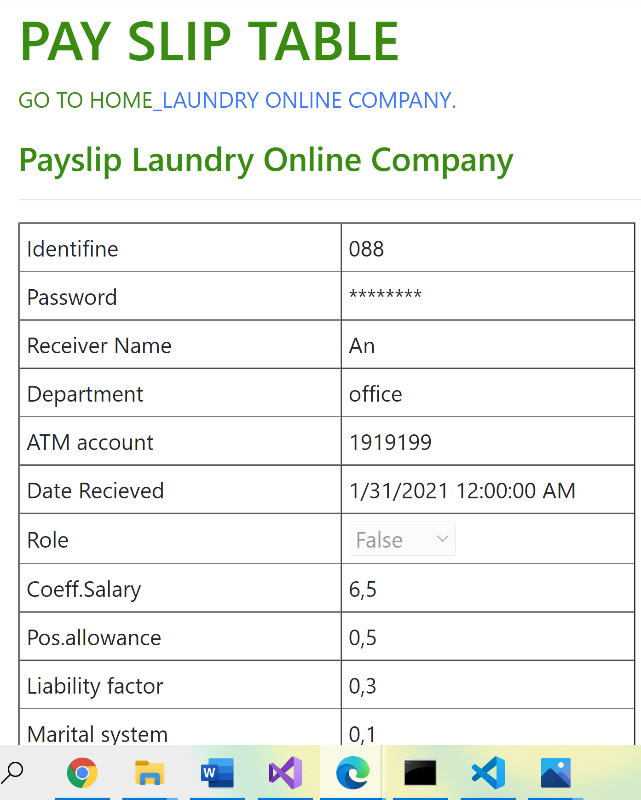

**4.2.2.2/- For Employee as Leader**

Leader can see details, create new pay slip, update, edit, delete payslip for each staf include him self; To see total salary of company in that month.

Employee => Id (in this case defalt Id = 001) => Password (in this case default value is 123) => Payroll table of company:

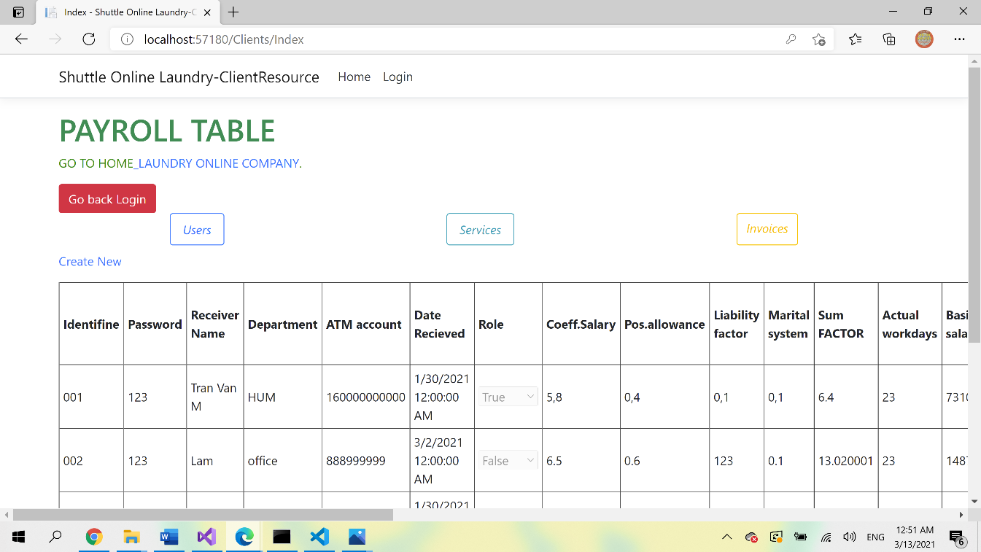

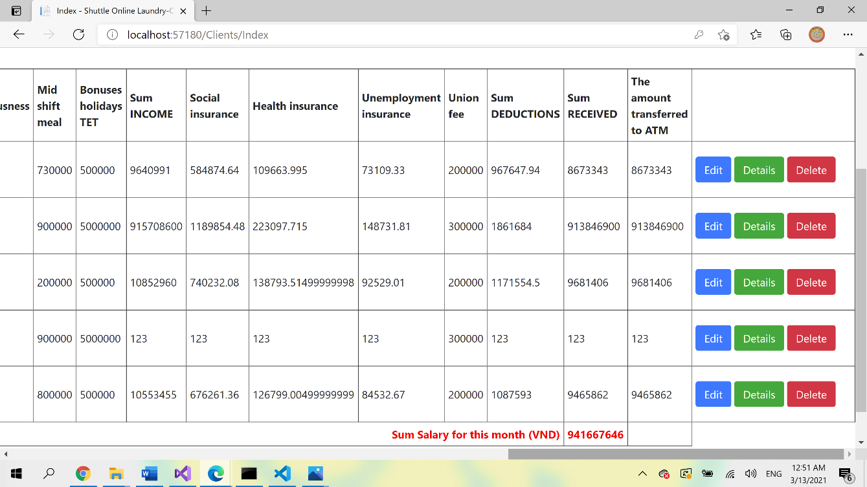

Roll Leader and satf created in database.

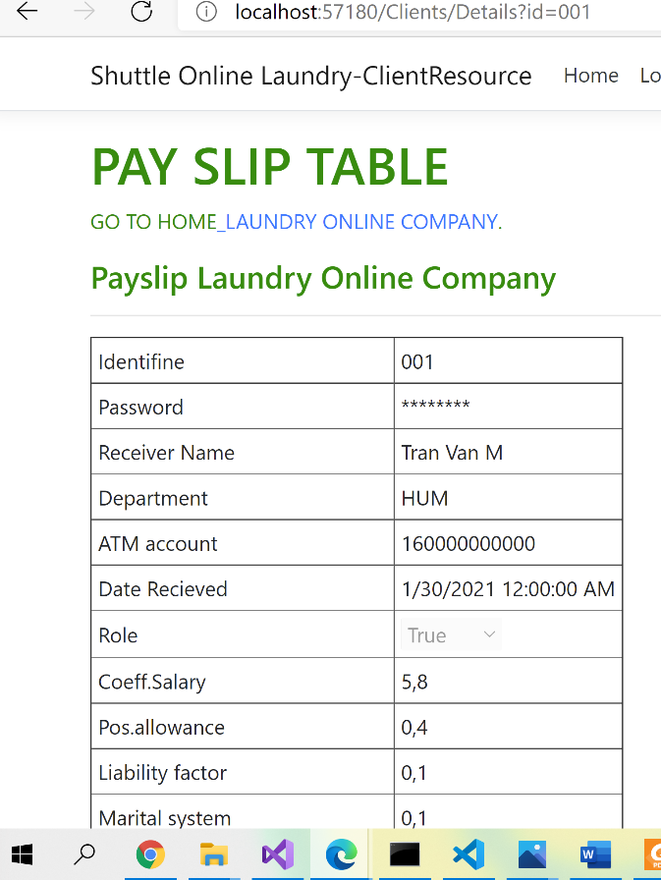

**Beside that, Leder can cotrole Customers, services, invoices tables :**

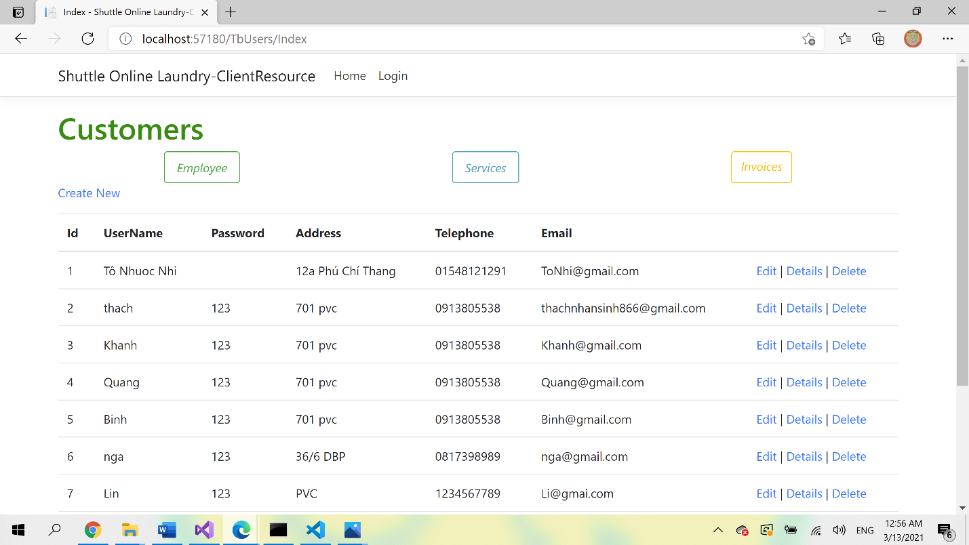

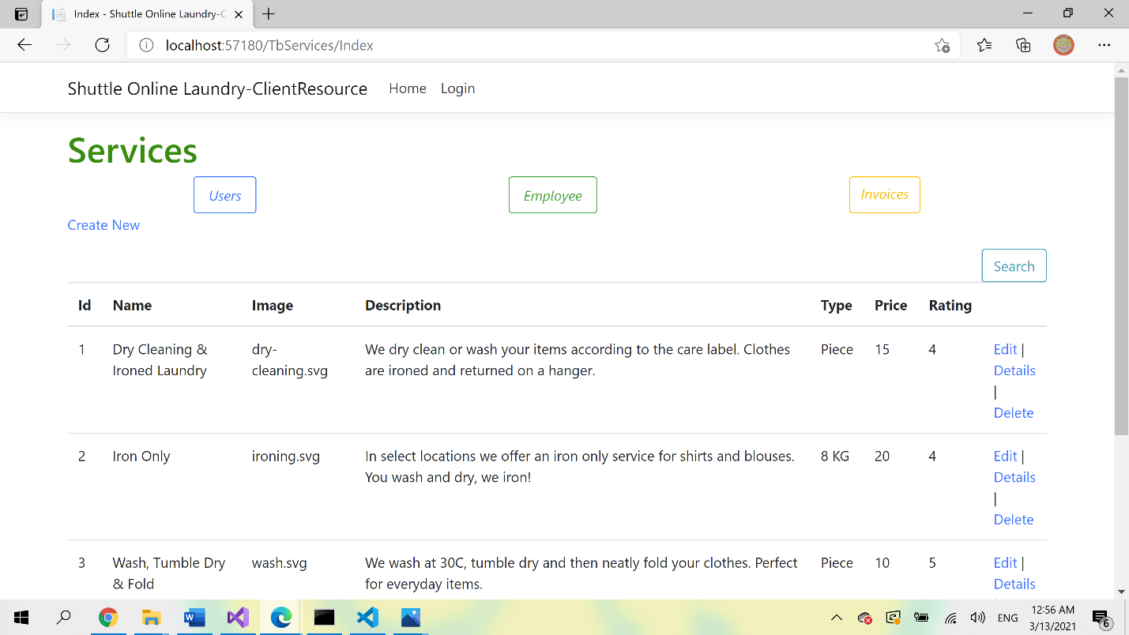

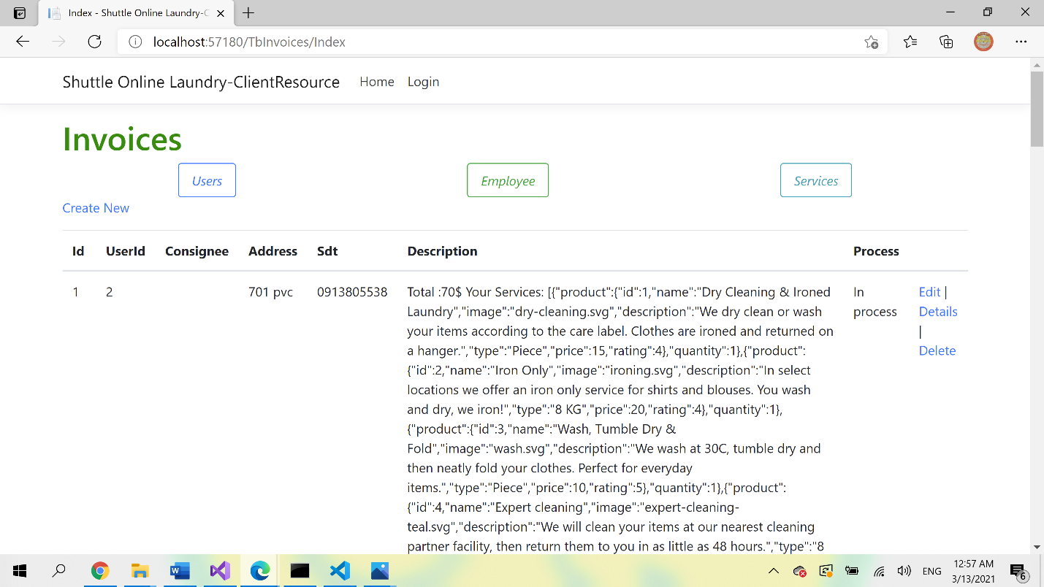

You can conext with other social pages: Google; Twister; Facebook, music, Google map (etc)..…by clik on these icons on our home page

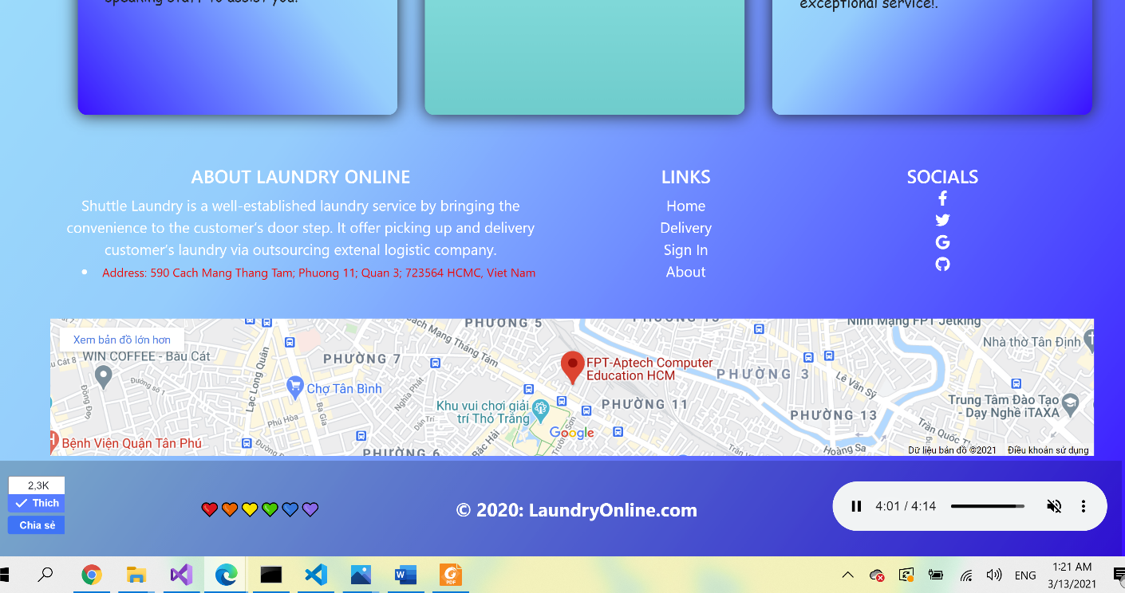

REVIEW 3 – TASK SHEET

|  |  |  |  |  |  |
| --- | --- | --- | --- | --- | --- |
| No. | Contents | Member | Activity Plan | Preparation | |
| Start Date | Actual Days | Status |
| 1 | Database design | Nguyen Ngoc Thach  Quach Gia Lam  Pham Anh Duc  Hoang Toan Thang | 05/03/2021 | 30 | Completed |
| 2 | ASP.NET Core |
| 3 | ReactClient |
| 4 | Tecnology |
| 5 | Front ent |
| 6 | Front back |
| 7 | Documentation |

Plan prepared by: Group 2 Map 18st, 20201  
 **Group Leader Faculty**

**Hoang Toan Thang Mr. Ngo Phuoc Nguyen**